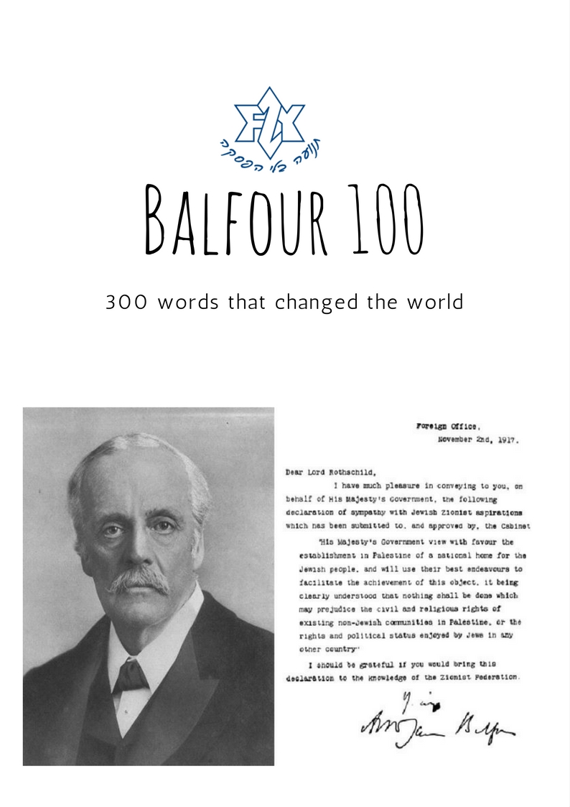

Dear Livnot-nik,
Welcome to the second educational pack that we are sending you.
In this pack, we will discuss the Balfour Declaration and the impact it had on Israel’s establishment and on the Jewish-Arab conflict. We will also explore the British connection to all of that.
The first part provides a general overview to the situation and the people responsible for the Declaration.
The second part will be dedicated to other declarations and agreements that were also made around the same time as the Balfour Declaration. These might influence the way that we understand the Declaration today.
In the third part, we will take a look at some articles about the Balfour Declaration. These different opinions and difficult questions should provide a useful opportunity to challenge us.
Although this pack is a bit less about Israel and a bit more about general history, this history is important if we want to understand the context and background for the establishment of Medinat Israel.
Just like last time, each of you will read the whole pack, but you will focus on one or two sections. Then, when we meet as a group, you’ll be responsible for explaining your sections when we meet as a group.
Please highlight some key points that make for good discussion when we meet!
The sections that you are in charge of are:

__________________________________________________________
You don’t have to memorize it; just read and understand. Think about how your section relates to the main theme of the pack. When we meet, tell us what you took from your sections, and the discussion will begin from there.
The idea is that it is not just about knowing things; it is equally important to process your thoughts and decide what you, as a Jew and as a Zionist, think about it.
We hope you find this useful.
See you soon!

Your Movement Team

Timeline 1915-1948:
1915: Sir Henry McMahon offers Sharif Hussein support for an Arab State excluding areas West of Damascus, if he helps the British against the Ottomans.
1916: The secret Sykes-Picot agreement divides the Middle East between France and Britain.
1917: Great Britain, during World War I, issues the Balfour Declaration, promising a Jewish national home in Palestine.
1922: After the Ottoman Empire is defeated in World War I, the League of Nations confirms the British mandates over Iraq and Palestine, and a French mandate over Syria and Lebanon. Transjordan is separated from the Palestine Mandate and becomes an autonomous kingdom.
1936: Palestinian Arabs demand a halt to Jewish immigration and a ban on land sales to Jews. British troops attempt to assert control, but violence continues. Britain hangs or imprisons most of the Arab leadership. The Peel Commission recommends partition of Palestine between Arabs and Jews.
1939: Britain announces severe restrictions on Jewish immigration and land purchases in Palestine. Violence erupts from Jewish militants.
1947: Britain lets the United Nations decide what to do about Palestine, which is partitioned into Jewish, Arab, and international areas (Jerusalem and Bethlehem). Fifty-five percent of the territory is allocated to the Jewish state.
1948: The British mandate over Palestine terminates. Israel declares independence and Truman recognises Israel. Count Bernadotte appointed as UN mediator.

The Balfour declaration- Background:
On 2 November 1917, Foreign Secretary Arthur James Balfour writes a letter to Britain’s most illustrious Jewish citizen, Baron Lionel Walter Rothschild, expressing the British government’s support for a Jewish homeland in Palestine.
Britain’s public acknowledgement and support of the Zionist movement emerged from its growing concern surrounding the direction of the First World War. By mid-1917, Britain and France were mired in a virtual stalemate with Germany on the Western Front, while efforts to defeat Turkey on the Gallipoli Peninsula had failed spectacularly. On the Eastern Front, the fate of one ally, Russia, was uncertain: revolution in March had toppled Czar Nicholas II, and the provisional government was struggling against widespread opposition to maintain the country’s disintegrating war effort against Germany and Austria-Hungary. Although the United States had just entered the war on the Allied side, a sizeable infusion of American troops was not scheduled to arrive on the continent until the following year.
Against this backdrop, the government of Prime Minister David Lloyd George—elected in December 1916—made the decision to publicly support Zionism, a movement led in Britain by Chaim Weizmann, a Russian Jewish chemist who had settled in Manchester. The motives behind this decision were various: aside from a genuine belief in the righteousness of the Zionist cause, held by Lloyd George among others, Britain’s leaders hoped that a formal declaration in favour of Zionism would help gain Jewish support for the Allies in neutral countries, in the United States and especially in Russia, where the powerfully anti-Semitic czarist government had just been overthrown with the help of Russia’s significant Jewish population. Finally, despite Britain’s earlier agreement with France dividing influence in the region after the presumed defeat of the Ottoman Empire, Lloyd George had come to see British dominance in Palestine—a land bridge between the crucial territories of India and Egypt—as an essential post-war goal. The establishment of a Zionist state there—under British protection—would accomplish this, while seemingly following the stated Allied aim of self-determination for smaller nations.
Over the course of 1917, a vigorous anti-Zionist movement within Parliament held up the progress of the planned declaration. Led by Edwin Montagu, secretary of state for India and one of the first Jews to serve in the cabinet, the anti-Zionists feared that British-sponsored Zionism would threaten the status of Jews who had settled in various European and American cities and also encourage anti-Semitic violence in the countries battling Britain in the war, especially within the Ottoman Empire. This opposition was overruled, however, and after soliciting—with varying degrees of success—the approval of France, the United States and Italy (including the Vatican), Lloyd George’s government went ahead with its plan.
On 2 November, Balfour sent a letter to Lord Rothschild, a prominent Zionist and a friend of Chaim Weizmann, stating that:
“His Majesty’s Government view with favour the establishment in Palestine of a national home for the Jewish people, and will use their best endeavours to facilitate the achievement of this object, it being clearly understood that nothing shall be done which may prejudice the civil and religious rights of existing non-Jewish communities in Palestine, or the rights and political status enjoyed by Jews in any other country.”
By the time the statement was published in British and international newspapers one week later, one of its major objectives had been rendered obsolete: Vladimir Lenin’s Bolsheviks had gained power in Russia, and one of their first actions was to call for an immediate armistice. Russia was out of the war, and no amount of persuasion from Zionist Jews—who, despite Britain’s belief to the contrary, had relatively little influence in the country to begin with—could reverse the outcome.
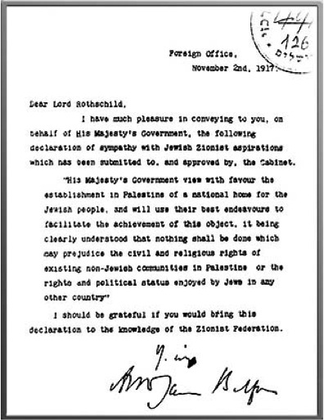
Nonetheless, the influence of the Balfour Declaration on the course of post-war events was immediate. According to the “mandate” system created by the Versailles Treaty of 1919, Britain was entrusted with the temporary administration of Palestine, with the understanding that it would work on behalf of both its Jewish and Arab inhabitants. Many Arabs, in Palestine and elsewhere, were angered by their failure to receive the nationhood and self-government they had been led to expect in return for their participation in the war against Turkey. In the years after the war, the Jewish population in Palestine increased dramatically, along with instances of Jewish-Arab violence. The area’s instability led Britain to delay making a decision on Palestine’s future. In the aftermath of World War II and the terrors of the Holocaust, however, growing international support for Zionism led to the official declaration in 1948 of the State of Israel.

Important figures:
Arthur James Balfour:
Arthur Balfour was born on the family's Scottish estate in East Lothian in 1848. Educated at Eton and Trinity College, Cambridge, he entered the House of Commons in 1874 as the Conservative MP for Hertford.

In 1878 Balfour became private secretary to his uncle, the Marquess of Salisbury.

In the 1885 General Election Balfour was elected to represent the East Manchester constituency. The Marquess of Salisbury, who was now Prime Minister, appointed him as his Secretary for Scotland. Other posts during the next few years included Chief Secretary of Ireland (1887), First Lord of the Treasury (1892) and leader of the House of Commons (1892).

Balfour replaced his uncle as Prime Minister in 1902. The most important events during his premiership included the 1902 Education Act and the ending of the Boer War. The topic of Tariff Reform split Balfour's government and when he resigned in 1905, Edward VII invited Henry Campbell-Bannerman to form a government. Campbell-Bannerman accepted and in the 1906 General Election that followed the Liberal Party had a landslide victory.

He remained leader of the Conservative Party until he was replaced by Andrew Bonar Law in 1911. He returned to government when in 1915 Herbert Asquith offered him the post of First Lord of the Admiralty in Britain's First World War coalition government. The following year, David Lloyd George, the new Prime Minister, appointed him as Foreign Secretary, and consequently was responsible for the Balfour Declaration in 1917 which promised Zionists a national home in Palestine.

As Balfour saw it, Zionism was the solution to the Jewish problem: “If a place were provided for them in the land of their historic origins, the Jews would be given the choice of assimilation in their adopted countries or Jewish citizenship in their ancient homeland.” Thus, he told the War Cabinet in October 1917, “any danger of a double allegiance or non-national outlook would be eliminated.”

After much back and forth on the precise wording of the declaration to be put before the ministers and with solid backing from Lloyd George, Balfour won the cabinet’s approval. And on November 2, 1917, on behalf of His Majesty’s Government, Balfour wrote the now familiar letter addressed to Lord Rothschild that committed Britain to supporting the creation of a Jewish national home in Palestine.

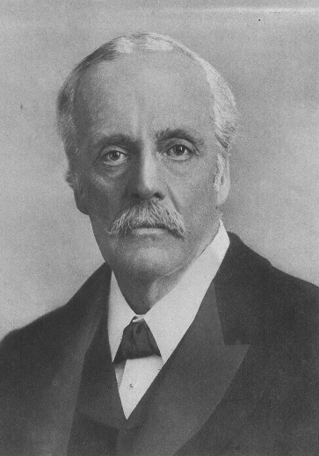
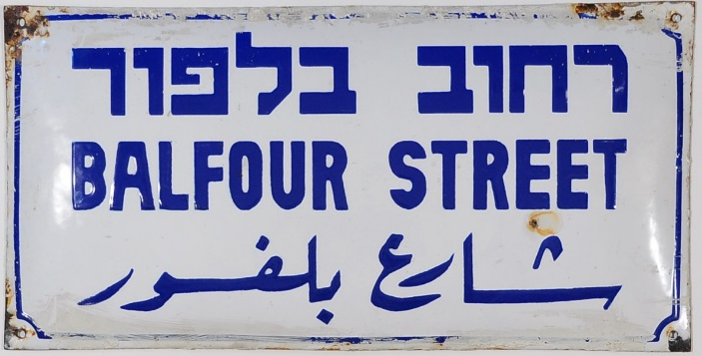

Lionel Walter Rothschild:
The document that came to be known as the Balfour Declaration was addressed to Lionel Walter Rothschild and delivered by hand to his London home at 148 Piccadilly.

Born into the Rothschild banking family, Walter ‎took on the business and civic responsibilities necessitated by his position. He served as a Conservative member of the House of Commons and on the boards of Jewish communal institutions. His attachment to Zionism was heartfelt and of incalculable value to the movement; yet his greatest passion was reflected in his lifelong commitment to the natural sciences.

Lionel Walter Rothschild was born in London. Between 1889 and 1908 he worked at N. M. Rothschild & Sons in London. In tandem he served as a Member of Parliament with the Liberal-Unionists (from 1899 to 1910), a faction that had broken away from the Liberal Party in opposition to Irish Home Rule.

By 1910 Walter had retired from parliament and banking to devote himself to the natural sciences. He wrote scores of well-received articles on biology, zoology, ornithology and entomology. An avid collector, he opened a public museum at Tring in Hertfordshire that housed his specimen collection—just as he had said he would when he was only seven years old.

Besides being a trustee of the British Museum, Rothschild was the de facto head of Britain’s Jewish community serving as a governor of the Board of Deputies, of the United Synagogue, of the Anglo Jewish Association, and of the Jews’ Free School.

When Nathaniel Mayer de Rothschild died in 1915, Walter succeeded his father to the peerage.
Rothschild, furthermore, worked diligently with Weizmann to counter the influence of ‎the Jewish anti-Zionists both in and outside the British Cabinet. On February 7, ‎‎1917 he told his coterie of Zionist insiders—in the presence of Sir Mark Sykes, ‎the Middle East strategist and government emissary— that he was for a Jewish ‎state under the sponsorship of the British crown. ‎

In response to those anti-Zionists who worried that the ‎rights of British Jewry would be jeopardized if Zionism were ‎embraced abroad, Rothschild argued that a Jewish homeland in Palestine under British ‎protection was meant for those who “could not” or “did not” desire to be ‎citizens in the country where they lived.

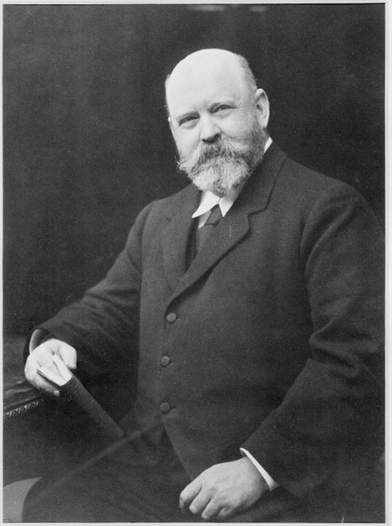

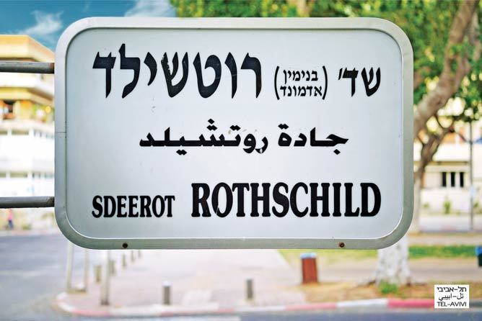

Leo Leopold Amery:

Amery started out on the editorial staff of The Times (1899-1909) having been a correspondent for the paper during the Boer War (1899-1900).

As Assistant Secretary to the War Cabinet (1917–18), Amery wrote one of the drafts which ultimately became the Balfour Declaration.

Just before the War Cabinet met on October 4, 1917, as Amery recalled in his diary, Lord Alfred Milner—Amery’s mentor, an influential force in the Cabinet and himself a pro-Zionist—asked him to draft “something which would go a reasonable distance to meeting the objections both Jewish and pro-Arab without impairing the substance of the proposed declaration.”

The resultant Milner-Amery draft, written under extreme time pressure, contained the essential points of the final draft though it referred to the Jewish “race” instead of “people” and had a slightly drawn-out formula regarding “the rights and political status enjoyed in any other country by such Jews who are fully contented with their existing nationality (and citizenship)” and would not move to Palestine.

Also in 1917, Amery had facilitated Ze’ev Jabotinsky, the Zionist leader, in gaining official British approval for the formation of the Jewish Legion.

Amery hid his Jewish lineage during his lifetime even as he championed Zionism against both Jewish and non-Jewish foes.

In a bizarre twist to the revelations about Amery’s Jewish heritage, his eldest son, John (1912-1945) lived in Germany during WWII as a Nazi propagandist broadcasting to Britain. Despite his father’s efforts to save him, John Amery was hanged for treason in 1945.

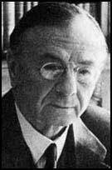

David Lloyd George:

David Lloyd George was the leader of the Liberal Party and Prime Minister in the Coalition Government (between 1916 and 1922) under whose rule the 1917 Balfour Declaration was approved. His support guaranteed that the Zionist case was placed on the War Cabinet's agenda. A dynamic figure, Lloyd George was no less instrumental in ensuring that the Declaration gained subsequent international legal authority.

The Versailles Peace Conference after World War I led to the founding of the League of Nations and a Mandate system to oversee former German and Turkish territories. Britain's Mandate for Palestine was granted in 1920 at the San Remo conference and approved by the League in 1922. Lloyd George played an essential role every step of the way.

While subsequent British governments and civil servants backpedalled on the spirit of the Balfour Declaration, throughout his life David Lloyd George remained committed to upholding its principles. While not devoid of “ordinary” anti-Semitism, David Lloyd George was drawn towards the idea of a homeland for the Jewish people partly by his Christian upbringing. “I was taught far more about the history of the Jews than about the history of my own people,” he wrote. “We were thoroughly versed in the history of the Hebrews.”

Lloyd George first came into contact with the Zionist idea in July 1903, when as a solicitor he helped lay the legal groundwork for the Uganda Plan, a scheme that would have created a refuge for persecuted Jews in British East Africa.

Britain declared war against Germany on August 4, 1914; its declaration of war against Turkey did not come until November 5 of that year. That is when Lloyd George, then Chancellor of the Exchequer, said in a conversation with Herbert Samuel, a Zionist, fellow Liberal Party MP, and the first non-baptized Jew to serve in the Cabinet, that he “was very keen to see a Jewish State established in Palestine.”

When he first met the preeminent Zionist leader Chaim Weizmann in December 1914—at the behest of his friend, fellow Liberal Party MP and Manchester Guardian editor C.P. Scott—Lloyd George was already receptive to Zionism.

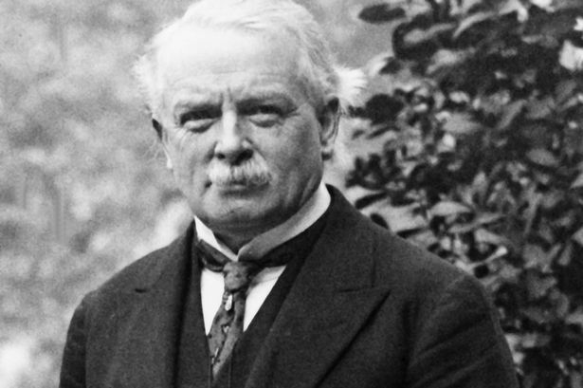
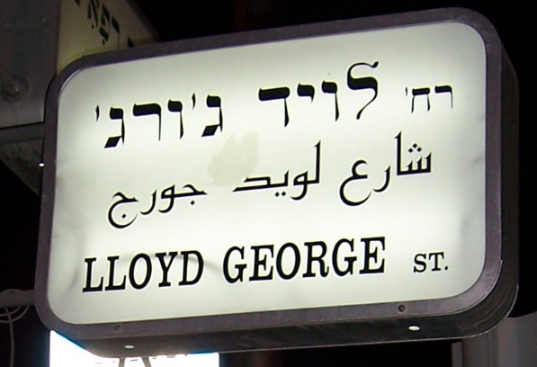

The Hussein-McMahon correspondence
Ḥusayn-McMahon correspondence was a series of letters exchanged in 1915–16, during World War I, between Ḥusayn ibn ʿAlī, emir of Mecca, and Sir Henry McMahon, the British high commissioner in Egypt. In general terms, the correspondence effectively traded British support of an independent Arab state in exchange for Arab assistance in opposing the Ottoman Empire. It was later contradicted by the incompatible terms of the Sykes-Picot Agreement, secretly concluded between Britain and France in May 1916 (see page 12), and Britain’s Balfour Declaration of 1917.

In July 1915 Ḥusayn took the opportunity to send a letter to McMahon detailing the conditions under which he would consider a partnership with the British. Ḥusayn, who claimed to represent all Arabs, effectively sought independence for the entirety of the Arabic-speaking lands to the east of Egypt. McMahon, however, insisted that certain areas falling within the French sphere of influence, such as the districts of Mersina and Alexandretta and land lying west of Damascus, would not be included and emphasized that British interests in Baghdad and Basra would require special consideration. Ḥusayn disagreed with the exception of the French-claimed areas and stipulated that certain rules had to govern British activity in Baghdad and Basra, terms to which McMahon did not give his assent; in the end, the matters were set aside for discussion at a later date. Ultimately, the highly ambiguous correspondence was in no way a formal treaty, and disagreements on several points persisted unresolved.

In addition to disagreements within the letters themselves, conflicts of interest were magnified by secret negotiations between Britain and France that culminated in 1916 in the Sykes-Picot Agreement, which effectively re-portioned between them the entirety of the Ottoman Empire, and later by the Balfour Declaration, which assured British support for the establishment in Palestine of a national home for the Jewish people. Ḥusayn, however, apparently sufficiently convinced of British support, announced the launch of his Arab revolt against the Ottomans in June 1916. Although the revolt was relatively minor, with British backing the Arab forces succeeded in dominating the Hejazregion of the Arabian Peninsula, as well as Al-ʿAqabah and Damascus.

The Ḥusayn-McMahon correspondence remained a point of heated contention thereafter, particularly as it related to Palestine, which the British claimed was included in the land to be set aside for the French. Although it is uncertain precisely what Ḥusayn expected or even what exactly McMahon had offered, it is certain that the Arabs achieved far less from the ambiguous arrangement than they had anticipated.

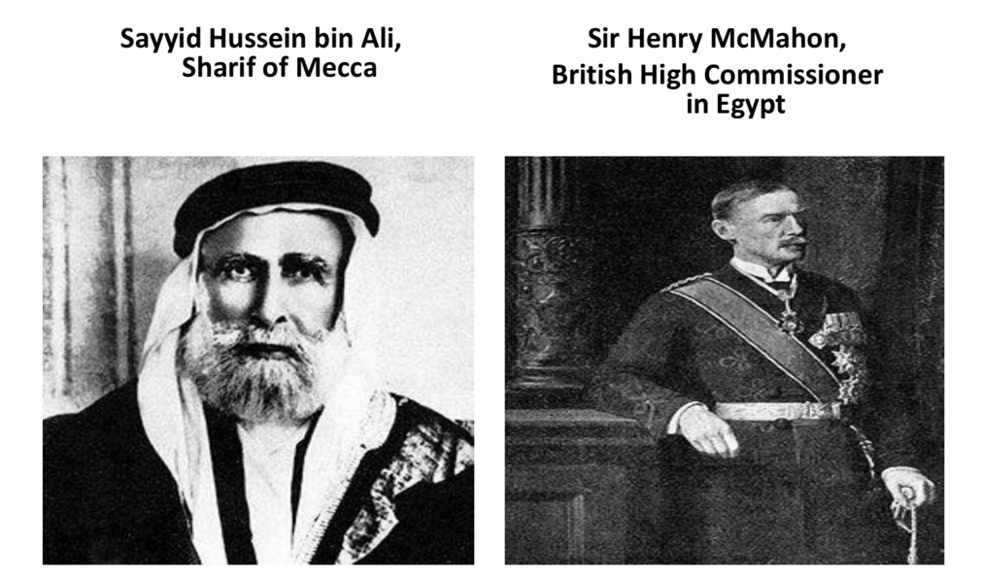
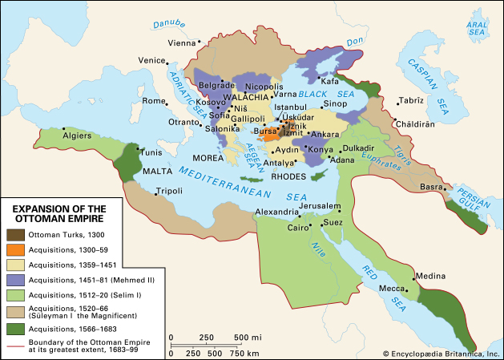

The Sykes-Picot agreement:
The Sykes–Picot Agreement was a secret 1916 agreement between the United Kingdom and France, to which the Russian Empire assented. The agreement defined their mutually agreed spheres of influence and control in Southwestern Asia. The agreement was based on the premise that the Triple Entente would succeed in defeating the Ottoman Empire during World War I. The negotiations leading to the agreement occurred between November 1915 and March 1916 and it was signed 16 May 1916. The deal, exposed to the public in Izvestia and Pravda on 23 November 1917 and in the British Guardian on November 26, 1917, is still mentioned when considering the region and its present-day conflicts.
The agreement allocated to Britain control of areas roughly comprising the coastal strip between the Mediterranean Sea and the River Jordan, Jordan, southern Iraq, and an additional small area that included the ports of Haifa and Acre, to allow access to the Mediterranean. France got control of south-eastern Turkey, northern Iraq, Syria and Lebanon. Russia was to get Istanbul, the Turkish Straits and Armenia. The controlling powers were left free to determine state boundaries within their areas. Further negotiation was expected to determine international administration in the "brown area" (an area including Jerusalem, similar to and smaller than Mandate Palestine), the form of which was to be decided upon after consultation with Russia, and subsequently in consultation with the other Allies, and the representatives of Hussein bin Ali, Sharif of Mecca.
The agreement effectively divided the Ottoman Arab provinces outside the Arabian Peninsula into areas of British and French control and influence, and led later to the subsequent Empire following Ottoman defeat in 1918. The Acre-Haifa zone was intended to be a British enclave in the North to enable access to the Mediterranean. The British later gained control of the brown zone and other territory in 1920 and ruled it as Mandatory Palestine from 1923 until 1948. They also ruled Mandatory Iraq from 1920 until 1932, while the French Mandate for Syria and the Lebanon lasted from 1923 to 1946. The terms were negotiated by British diplomat Mark Sykes and a French counterpart, François Georges-Picot. The Tsarist government was a minor party to the Sykes–Picot agreement, and when, following the Russian Revolution, the Bolsheviks published the agreement on 23 November 1917, "the British were embarrassed, the Arabs dismayed and the Turks delighted".
The agreement is seen by many as a turning point in Western and Arab relations. It negated the UK's promises to Arabs made for a national Arab homeland in the area of Greater Syria, in exchange for supporting the British against the Ottoman Empire.
Many sources contend that Sykes-Picot conflicted with the Hussein–McMahon Correspondence of 1915–1916 (See page 10) and that the publication of the agreement in November 1917 caused the resignation of Sir Henry McMahon. There were several points of difference, the most obvious being Iraq placed in the British red area and less obviously, the idea that British and French advisors would be in control of the area designated as being for an Arab State. Lastly, while the correspondence made no mention of Palestine, Haifa and Acre were to be British and the brown area (a reduced Palestine) internationalised.
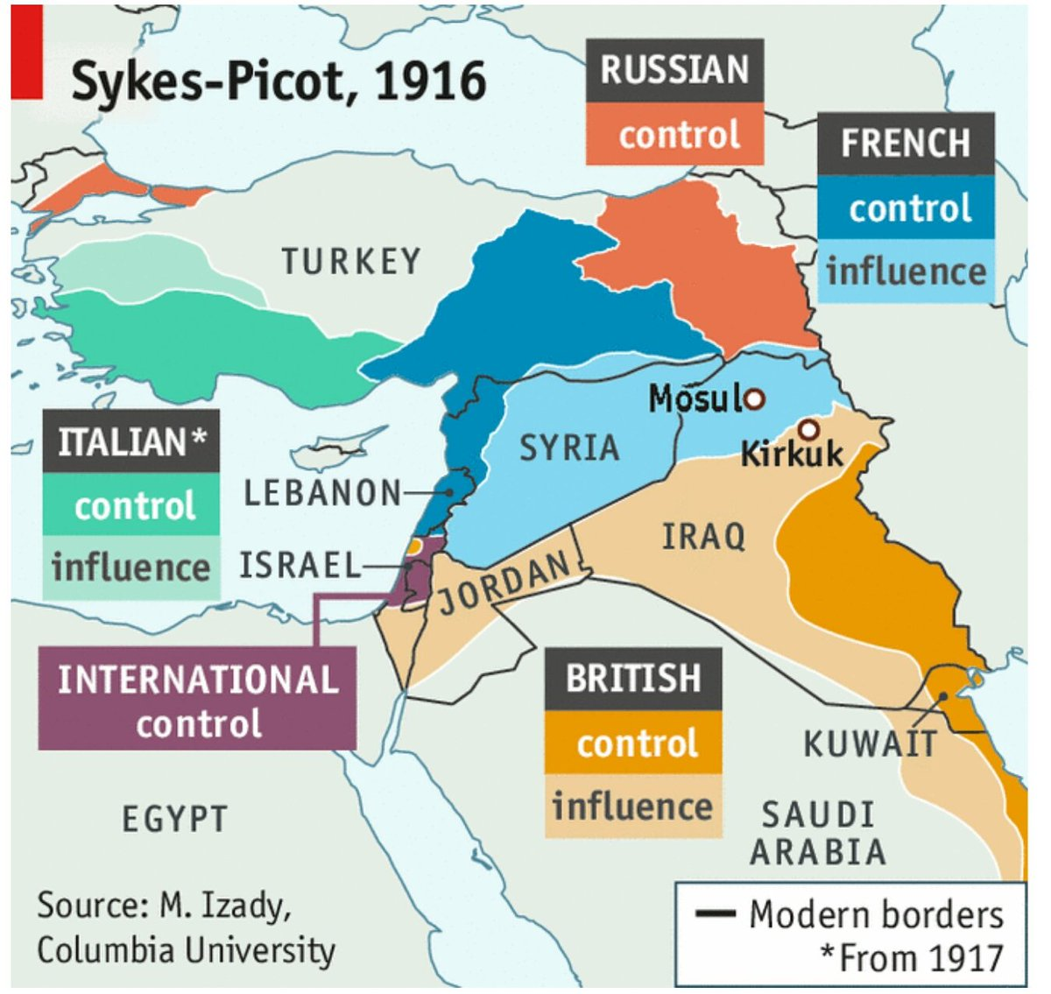
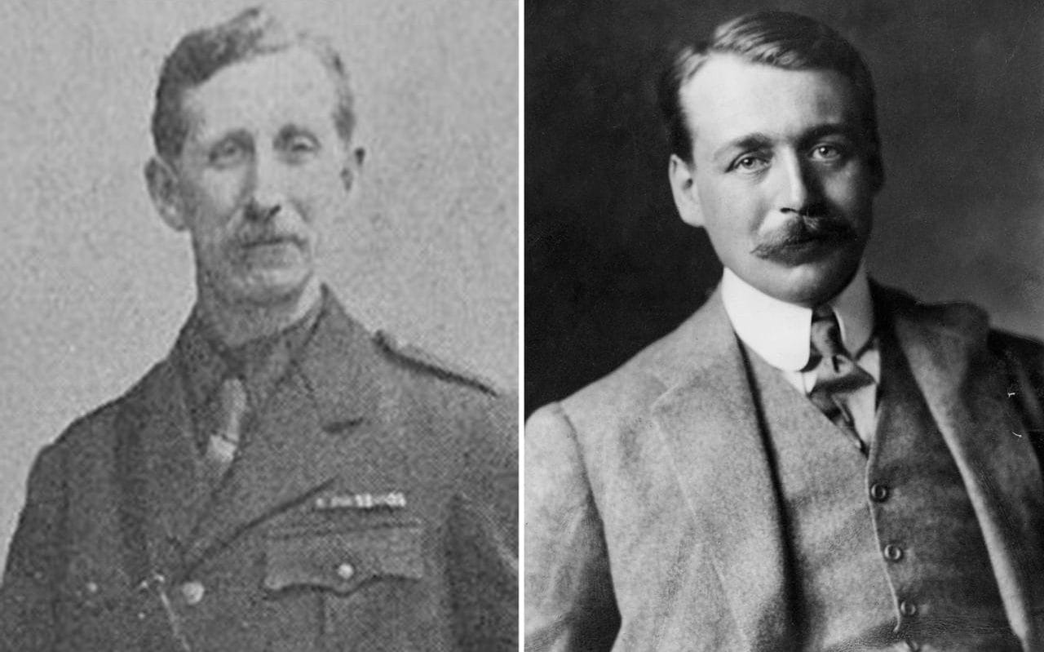

The "Ottoman Balfour Declaration”:

In October 1917, as British forces knocked at Jerusalem's gates, the Ottoman authorities declared a string of draconian steps aimed at destroying the Jewish community in Palestine (the Yishuv). Should the Turks be driven from Palestine, threatened Djemal Pasha, governor of the Levant and one of the triumvirs who ran the Ottoman Empire during World War I, no Jews would live to welcome the British forces.

Less than a year later, on August 12, 1918, Grand Vizier Talaat Pasha, Djemal's co-triumvir, issued an official declaration in the name of the Ottoman government abolishing these restrictions and expressing sympathy "for the establishment of a religious and national Jewish centre in Palestine by well-organized immigration and colonization."

Though issued far too late to have any concrete effect—nearly half a year after the British conquest of Palestine and some eighty days before the Ottoman surrender—the significance of the declaration cannot be overstated. Here was the world's foremost Muslim power mirroring the British government's recognition (in the November 1917 Balfour Declaration) of the Jewish right to national revival in Palestine, something that many Muslim states refuse to acknowledge to date.

Why the Declaration?

Its non-implementation notwithstanding, Talaat's original statement was extraordinary in two key respects: the religious and the national. On the former level, the pledge to treat Palestine's Jewish community on the basis of "complete equality with the other elements of the population" ran counter to the socio-political order of things underpinning the House of Islam, whereby political power was vested with the Muslim majority whereas non-Muslim minorities were tolerated subjects (or dhimmis), who enjoyed protection and autonomy in the practice of their religious affairs yet were legally, institutionally, and socially inferior to their Muslim rulers.

Likewise, the sympathetic allusion to "the Jewish nation," let alone to the creation of a "Jewish national centre in Palestine," was antithetical to the millenarian perception of Jews as a religious community rather than a national group. Moreover, having been squeezed out of their European colonies in the nineteenth century by the rising force of nationalism (resulting in the independent states of Greece, Romania, Bulgaria, Serbia, Montenegro, and Albania), the Ottomans were resolved to prevent the recurrence of this phenomenon in their Afro-Asiatic provinces. Hence their brutal repression of the Armenian national awakening in the 1890s—in which some 200,000 people perished and thousands more fled to Europe and America—was a taste of the genocidal horrors that awaited the Armenians during World War I. These atrocities also foreshadowed the repression of the Yishuv throughout the war, which was demonstrated most starkly by mass expulsions of Jews from Palestine and the sustained attempt in the spring through autumn 1917 to uproot the Tel-Aviv-Jaffa community.

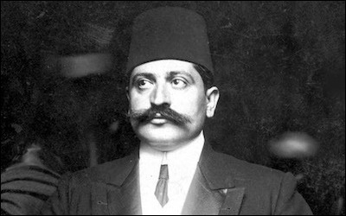

Opinions on the Balfour declaration:
The next few articles have been published in different online magazines:

6
Balfour Just isn’t that big of a deal (Galia Golan, Times of Israel):
Granted, the declaration was of great importance at the time, enabling continued Jewish immigration to Palestine during the pre-state years of the Zionist movement. It was a green light for that immigration, accorded by the colonialist power in the region. It arguably led to a significant increase in the number of Jews who came to the territory. But it was not the number of Jews actually here that brought about the legitimization of the creation of the state. Jews were a relatively small minority, 608,000 Jews as distinct from 1,237,000 non-Jews in 1947. What provided legitimacy for the creation of the state was UN General Assembly Resolution 181 – the Partition Plan for Palestine calling for a Jewish state (as well as an Arab one), approved by the international community as represented by the United Nations. And that legitimization came about as the result of a number of factors, the most important of which was the Holocaust.
Many important international documents and steps have ensued since the Balfour Declaration, providing and reaffirming the legitimacy of the state. Resolution 181 was the first and the most important, but UN Security Council Resolution 242 of November 1967 sought to reaffirm it. Once accepted by Egypt and Jordan in 1967, and later formalized by the peace treaties with these two countries, Israel was on the way to regional acceptance of its “right to exist within secure and recognized borders” – the text of UNSC Resolution 242. Perhaps the critical legitimization, however, came with the PLO acceptance of resolutions 181 and 242 in 1988, followed by the Oslo exchange of letters of mutual recognition in which Yasir Arafat made the following commitment: “The PLO recognizes the right of the State of Israel to exist in peace and security.”
Benjamin Netanyahu would have us, and the world, believe that the Palestinians have never recognized Israel, nor – more significantly – our “right” to live within recognized and secure borders. Menachem Begin once said that he did not need such recognition – our legitimacy, our right to a state here, he argued, was based on 2,000 years of history. But Israel, from 1948 onwards, bemoaned the absence of the Arab recognition of the State of Israel, later demanding that such recognition include our “right” to exist. Egypt’s Anwar Sadat appeared to offer this in his speech to the Knesset in 1977; Syria (belatedly) as well as Egypt and Jordan promised this in resolution 242 and the latter two actually implemented this with their peace treaties. The Palestinians did so in 1988 and again in 1993; and the entire Arab world – all 22 nations of the Arab League — did so in the Arab Peace Initiative of 2002.

Prof. Galia Golan is the author of Israeli Peacemaking since 1967: Factors behind the Breakthroughs and Failures, Routledge.

The Balfour declaration and the Palestine leadership Crises (Lior Weintraub, times of Israel):
Let’s be clear: the quintessential reason why the Palestinians find themselves in a miserable situation is not because of the Balfour Declaration. To the contrary, it is because they rejected it and every subsequent agreement that would have accorded them a state – alongside that of the Jews. The Palestinian leadership refused the British offer of a two-state solution in 1937. They rejected the U.N. partition plan of 1947. They failed to deliver their end of the bargain during President Clinton’s peace initiative in 2000 and, again, in 2007 during the Annapolis Conference initiated by the George W. Bush administration.
So, just as we are marking 100 years since the Balfour Declaration this week, so can we mark 100 years of the Palestinians’ rejectionist approach.
Israel has always demanded that the Palestinians recognize Israel as the homeland of the Jewish People and stop calls for its destruction. For many Israelis, accepting this symbolic request was a no brainer, a small gesture to ease the daunting security concerns given our partner’s poor track record and continuous support of terror. For many Israelis and Jews, the Palestinian refusal to do so is a glaring warning sign.
By declaring the Balfour Declaration and its provisions illegitimate, the Palestinians give their denial of Jewish rights to Israel a legal patina and a pretext for rejecting compromise with Israel.
The Palestinian rejectionist approach only serves as yet another sign for the vast majority of Israelis who want the peace process to succeed that the other side still doesn’t have the will or ability to live in peace on a basis of recognition and mutual respect. It is such approach that provides the history fans among us the needed context to view the situation nowadays.
While, back in 1917, Jewish leader Chaim Weitzman did not have a mandate from the Zionist movement to get Balfour to issue the famous declaration, he did not sit idly by. He went on to take the initiative and understood that diplomacy often demands uncomfortable compromises.
Across the seam, the Palestinian people’s greatest tragedy is their betrayal by their own leaders. Time and again, their well-being has been sacrificed on the altar of cynical political manoeuvres, leaving the Palestinian people impoverished, the Palestinian Authority unaccountable, and the Hamas leadership dwelling in luxury in exile.
The Balfour Declaration didn’t give the Jews their own state. But they took what they got and made the most of it. That is what Israel is all about. And unfortunately, the opposite is true for our Palestinian neighbours, whose worst enemies are not Israel, but their own leaders.
Lior Weintraub is Vice President of The Israel Project, a lecturer on Diplomacy and Communications at the IDC and former Chief of Staff at the Israeli Embassy in Washington.

The new Balfour Declaration (Published in +972 By Amjad Iraqi)
During a debate in the British Cabinet regarding its policy toward Palestine in 1919, Foreign Secretary Arthur Balfour informed Lord George Curzon, another senior statesman, that the government was not interested in “consulting the wishes of the present [Arab] inhabitants of the country” to help formulate its decisions. The great powers were “committed to Zionism,” he said, and Zionism was “of far profounder import than the desires and prejudices of the 700,000 Arabs who now inhabit that ancient land.”
Balfour’s sentiments echoed throughout President Donald Trump’s speech on Wednesday when he Jerusalem as the capital of Israel and announced the relocation of the U.S. embassy from Tel Aviv. Trump made no mention of the Palestinians’ history and belonging to the city, or the fact that over a third of its residents identify as Palestinian. He said that he would only support a two-state solution — and presumably, a Palestinian capital in East Jerusalem — if it was “agreed to by both sides.” The U.S. decision, he insisted, “is nothing more or less than a recognition of reality.”
The irony of Trump’s timing is not lost on Palestinians: last month marked the centenary of Lord Balfour’s infamous letter to Lord Walter Rothschild, a prominent Zionist activist, which promised British support for the creation of a Jewish homeland in Palestine.
Like Trump’s announcement, the Balfour Declaration was the outcome of several aligning interests and efforts, including the Zionist movement’s intensive lobbying, state officials’ evangelical Christian beliefs, and the imperial power’s strategic goals for the region. It not only prioritized Zionist claims over Arab rights, but elevated the Zionist movement from a nascent organization into a major political force.
It is too soon to tell whether Trump’s proclamation will have a similarly profound mark on the conflict; but in many ways, his speech has already inflicted significant damage. Like Balfour before him, Trump has energized Israel’s ethno-nationalist movement and dismissed the Palestinians’ indigenous right to their homeland.
By breaking with the international consensus, Trump has made the occupation of East Jerusalem an acceptable political norm; other allies like the Czech Republic, which declared West Jerusalem as Israel’s capital soon after Trump’s speech, may now be emboldened to follow suit. Moreover, by rewarding its colonial policies with a major symbolic victory, the U.S. has incentivized the Israeli government to complete its annexation of other parts of the occupied West Bank without fear of American backlash.
Thus despite his powerful legacy, the Palestinians that Lord Balfour so wilfully ignored have not been erased. Writing to Prime Minister David Lloyd George in 1919, Balfour admitted that “The weak point of our position is of course that in the case of Palestine we deliberately and rightly decline to accept the principle of self-determination.” A hundred years later, the demand for that right has only grown stronger.

Questions for discussion:

- What do you think about the wording of the Declaration? What does “view with favour” mean?
- What was the importance of the Balfour declaration, giving that it didn’t promise anything concrete?
- Galia Golan is saying that there are more important documents then the Balfour declaration, do you agree?
- What was the importance of the Othman declaration?
- How do the three agreements (The Hussein-McMahon correspondence, The Sykes-Picot agreement and the Balfour declaration) go hand in hand? Do they contradict each other or complete each other?
- What was the Balfour declaration’s effect on the Palestinians?
- What would have happen if the Balfour declaration had not taken place?
- What do you think about the comparison between the Balfour declaration and the “Trump declaration” 100 years after? Are there similarities? What are the differences?

