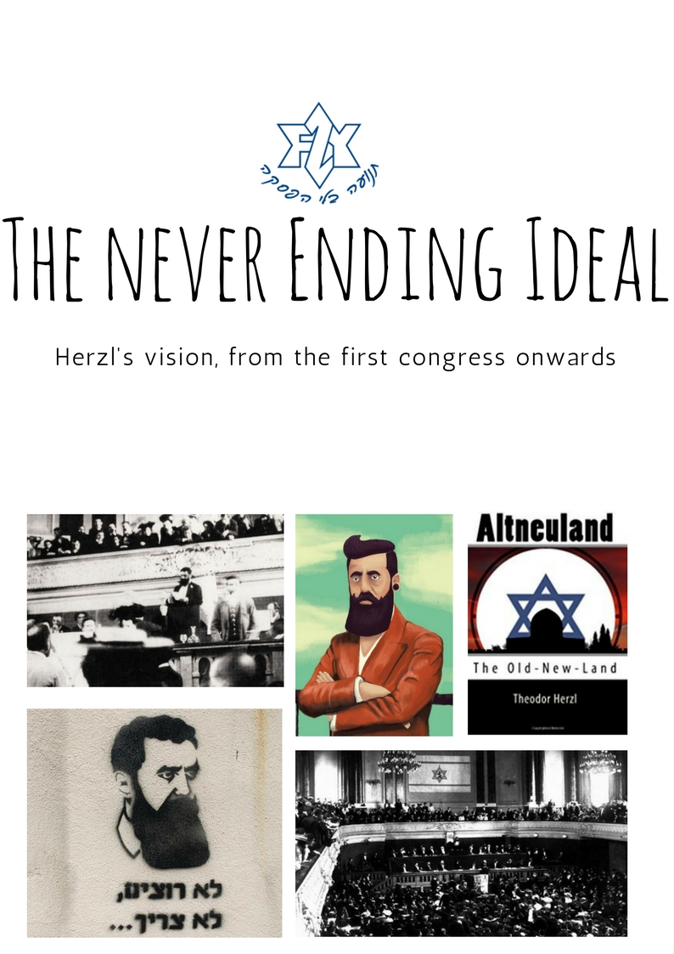

Dear Livnot-nik,
Welcome to the first educational pack that we are sending you.
In this pack, we will discuss the First Zionist Congress, and compare Zionism today to what it was back then. Wes will also compare Herzl’s vision for Israel to the reality today.
The first part will be a background to the first congress and the following congresses in Herzl’s times.
The second part will be dedicated to Altneuland, Herzl's novel in which he writes about his utopic and ideal Jewish land.
In the third part, we will take a look at some articles about Herzl and Zionism, and we will challenge ourselves with some different opinions and hard questions
So what do you do have to do?
Each of you will read the whole pack, but you will focus on one or two sections. Then, when we meet as a group, you’ll be responsible for explaining your sections when we meet as a group.
The sections that you are in charge of are:

__________________________________________________________
You don’t have to memorize it; just read and understand. Think about how your section relates to the main theme of the pack. When we meet, tell us what you took from your sections, and the discussion will begin from there.
The idea is that it is not just about knowing things; it is equally important to process your thoughts and decide what you, as a Jew and as a Zionist, think about these type of issues.
We hope you find this useful.
We will contact you in the next few days in order to set a date and time for us to meet.
See you soon!

Your movement team

Timeline of Zionism 1894 – 1920:

1894- Dreyfus Affair
1897- First Zionist Congress, Creation of the World Zionist Organisation (WZO)
1898- Second Congress - Basle, Switzerland

1899- Third Congress - Basle, Switzerland

1900- Fourth Congress - London, England

1901- Fifth Congress - Basle, Switzerland

1902- Altneuland published in Leipzig, Germany
1903- Sixth Congress - the Uganda plan is being offered
- - Theodor Herzl dies.

1914-1918- First World War.
1917- The Balfour Declaration.

- The British Mandate over Palestine begins.

- Chaim Weizmann is elected president of the World Zionist Organisation (WZO).

What is the first Zionist congress?
The first Zionist Congress was called by Theodor Herzl as a symbolic Parliament for those in sympathy with the implementation of Zionist goals. The Congress took place in the concert hall of the Basle Municipal Casino on August 29, 1897.

Shortly after the closing of the First Zionist Congress, Herzl famously wrote in his diary: “At Basel, I founded the Jewish state.” But even Basel was a second choice: Herzl had originally planned to “found” his state in Munich, a larger and more significant city than the quiet Swiss town that ended up serving as the venue for seven of the 11 Zionist Congresses that took place between 1897 and the start of World War I. It was the Jews of Munich — particularly the Orthodox and Reform leadership and those who were prominent in the city’s economic life — who were concerned that hosting the meeting would stir up trouble for them.

There is some dispute as to the exact number of participants at the First Zionist Congress; the approximate figure is 200 people from seventeen countries, 69 of whom were delegates from various Zionist societies and the remainder individual invitees. In attendance were also ten non-Jews who were expected to abstain from voting. Seventeen women attended the Congress, some of them in their own capacity and others who accompanied representatives. While women participated in the First Zionist Congress, they did not have voting rights. Full membership rights were accorded them the following year, at the Second Zionist Congress.

Herzl outlined his vision in his opening speech. One of the delegates, Mordecai Ben-Ami, described the reaction: “For a few moments, the hall shook from the shouts of joy, the applause, the cheers and the feet-stomping. It felt as if the great dream of our nation, of 2,000 years, was now solved, and in front us stood Mashiach Ben-David.”

Another delegate, Israel Zangwill, reflected on the atmosphere:
“On the rivers of Babylon we sat and wept when we remembered Zion. On the river of Basel we now sit and resolve: We will weep no more.”

Following a festive opening in which the representatives were expected to arrive in formal dress, tails and white tie, the Congress got down to the business at hand. The main items on the agenda were the presentation of Herzl's plans, the establishment of the World Zionist Organization and the declaration of Zionism's goals: the Basel program.

In the version submitted to the Congress on the second day of its deliberations (August 30) by a committee under the chairmanship of Max Nordau, it was stated: "The aim of Zionism is to create for the Jewish people a home in Eretz Israel secured by law."

At the Congress, Herzl was elected President of the Zionist Organization and Max Nordau one of three Vice-Presidents. Thereafter, the Zionist Congress met every year (1897-1901), then every second year (1903-1913, 1921-1939). Since World War II, meetings have been held approximately every four years.

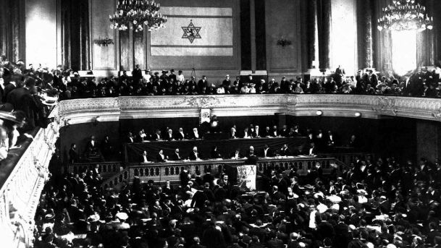

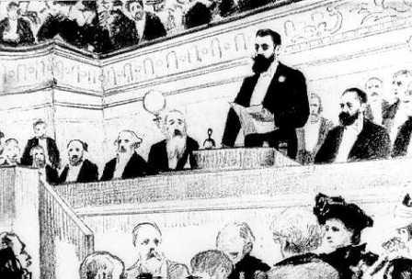

And then what happened? -A brief History of congresses 2-6:
Second Congress - Basle, Switzerland ,1898

- The foundations were laid for the establishment of the Jewish Colonial Trust, a financial body aimed at the development of Palestine.
- A group of Socialists first appeared demanding representation within the Zionist leadership.
- Woman were given voting privileges, an achievement considering that women still lacked the vote in Europe and the United States.

Third Congress - Basle, Switzerland ,1899

- Herzl opened the Third Congress with a report on his meetings with Kaiser William II in Constantinople and Jerusalem. Despite the fact that these meetings produced no practical results, the fact that they took place was of considerable symbolic value.
- In a debate on the Jewish Colonial Trust, Congress decided that its funds could only be spent in Palestine or Syria.
- Discussions on the question of culture—the Zionist attempt at a national/ethnic identity for the Jews.

Fourth Congress - London, England ,1900

- The Congress was held in London in order to affect public opinion in that country in sympathy with the Zionist idea.
- The Congress met in an atmosphere of growing concern over the situation facing Rumanian Jewry where many thousands had been forced to leave and the remainder were subject to persecution.
- On the cultural question, the religious Zionists led by Rabbi Yitzhak Ya’akov Reines demanded that the Zionist movement restrict itself solely to political matters.
- The Congress also discussed the problems of the Jewish workers in Palestine and the question of a national Jewish sports movement.

Fifth Congress - Basle, Switzerland, 1901

- Herzl reported to the Congress of his meeting with Sultan Abdul Hamid II of Turkey and of the progress of the Jewish Colonial Trust.
- The group led by Leo Motzkin, Martin Buber and Chaim Weizmann called on the Zionist movement to adopt a program of Hebrew culture and a greater degree of democracy within the organization.
- The more concrete achievement of the Congress was the establishment of the Jewish National Fund (JNF) which was to raise funds for land purchase in Palestine.

Sixth Congress - Basle, Switzerland, 1903

The British offered Herzl the possibility of an autonomous Jewish settlement in East Africa (commonly known as the Uganda project). Herzl called on the Congress to give serious consideration to the plan, even though he appreciated that it could not replace Palestine as the Jewish Homeland. In the lively debate that followed, Max Nordau, Herzl's major confidante, argued that “Uganda” would be a night refuge. Despite considerable opposition and a demonstrative walk-out by the Russian Zionists, the delegates agreed by 295 in favor, 178 against and 98 abstentions that a committee should be dispatched to examine the possibility of Jewish settlement in East Africa.
This was to be Herzl's last Congress: he died a year later.
Important figures (other than Herzl):
Max Nordau:

Max Nordau was a Hungarian Zionist leader who co-founded the World Zionist Congress and was instrumental in raising the "Uganda Plan" for a Jewish national home.

Considered a controversial author due to his attacks on contemporary European art, social and political behavior, Nordau's Conventional Lies of Society, written in 1883, was an attack on irrationality, egotism and nihilism which he perceived as the evils of his time. By 1898, his literary works were translated into some eighteen languages.

Nordau's Zionist conversion was an experience not dissimilar to Herzl's and he admitted that the rising tide of anti-Semitism had brought him back to realize his duties toward the Jewish people. When Herzl met with Nordau, it took little persuasion to convince the latter of the worthiness of the Jewish State idea.

Nordau soon became Herzl's partner in the Zionist movement playing a central role in defining the Basle program. At the first Zionist Congress, Nordau gave the opening speech on the condition of the Jewish people, which subsequently became a tradition at later Zionist Congresses.

At the Sixth Zionist Congress, Nordau defended Herzl's "Uganda Proposal" arguing that they offered a temporary solution to the Jewish people's sufferings. It was he who coined the term nachtasyl (night shelter) to describe the Uganda plan. Following Herzl's death, Nordau was offered the position of President of the World Zionist Organization but he declined preferring instead to serve as advisor to David Wolffsohn. He opposed the growing trend toward practical Zionism remaining faithful to Herzl's political program.

Nordau distanced himself from the Zionist movement but not from the idea. He last attended a Zionist Congress in 1911 and although resident in Spain during the First World War tried to maintain contact with the movement throughout that period. Weizmann attempted to bring him back into the organization at the end of the War; however, Nordau rejected the overtures, believing that the movement was a shadow of what Herzl had intended it to be.

In 1920 he raised the idea of evacuating half a million Jews from Europe to Eretz-Israel but no one took the idea seriously at that time. By then he had returned to Paris, where despite discussion of his immigration to Eretz-Israel he died after a long illness.

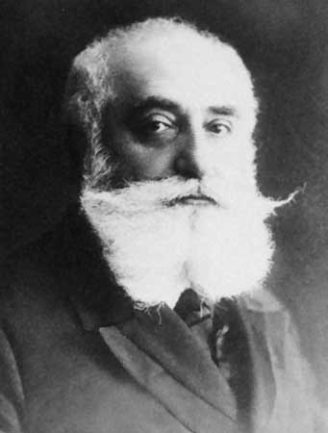
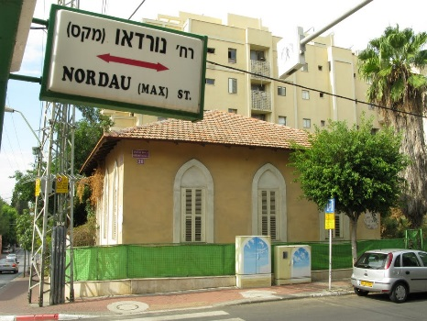

David Wolffsohn:

David Wolffsohn was born in Darbenai, Lithuania in 1856 where he received a traditional Jewish education. He moved in 1872 to Memel and then again to Lyck in East Prussia, finally making his home in Cologne in 1888. It was here that he became a successful businessman.

Wolffsohn had been active in Jewish affairs throughout his travels but it was in Cologne that he first became involved in Zionist activities. In 1893, together with Max Bodenheimer he established the Cologne Association for the Development of Agriculture in the Land of Israel, which was one of the Hovevei Zion groups of the time. In 1896, immediately after he heard of Herzl's impending publication of Der Judenstaat, Wolffsohn traveled to Vienna, to meet with the future leader of the Zionist movement. Wolffsohn soon became Herzl's associate and was a member of the Inner Actions Committee until 1904. He went with Herzl on his tour to Constantinople and EretzIsrael where they met with Kaiser Wilhelm II. Wolffsohn became one of the central figures in the establishment of the Jewish Colonial Trust and later became its first president. But in this capacity he experienced a number of differences with Herzl who despite his lack of financial experience interfered in the running of the bank.

Despite these difficulties, Wolffsohn remained loyal to Herzl even during the Uganda plan controversy and rather than to oppose the leader of the Zionist Organization, Wolffsohn maintained his silence. After Herzl's death, Wolffsohn assumed the position of President of the World Zionist Organization continuing the political and diplomatic priorities of his predecessor. The practical Zionists and the Democratic faction opposed his reelection in 1911 although he continued his work with the Jewish Colonial Trust. He died on September, 15, 1914, in Hamburg, Germany.

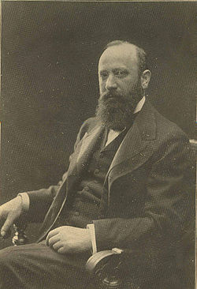


Leo Motzkin:
Leo Motzkin was born in present-day Brovary, Ukraine in 1867 and was raised in a traditional Jewish household. Motzkin became interested in the Zionist cause after witnessing the 1881 pogrom in Kiev. He joined the Russian-Jewish Academic Society at his university in Berlin, which consisted of other Jewish students dedicated to Hibbat Zion (Love of Zion). This group became a key forerunner of political Zionism. Its members actively debated other Jewish students on Zionist ideologies and means for settlement in Palestine. Following the completion of his studies, Motzkin chose Zionism as his life’s work, rather than pursue a career in the sciences.
At The First Zionist Congress, which he attended at the age of 30, Motzkin established himself as an outspoken advocate for the Basel Program for establishing a Jewish state; he advocated for diplomatic relations with the then-occupying government of Palestine, the Ottoman Empire. Following the Congress in 1897, Theodor Herzl sent Motzkin to Palestine on a fact finding mission. He returned with a critical opinion of the Hibbat Zion (Love of Zion) movement, because he adamantly opposed the mass-settlement and land purchasing program set into motion by the French philanthropist, Baron de Rothschild.
Motzkin was an advocate for the rights of Russian Jewry and the promotion of their self-defense. At the request of the Zionist Organization, he wrote a book about the wave of pogroms and Jewish suffering in Russia which was published in 1909 and 1910. He was somewhat unique in that he demanded that Zionists also concern themselves with the civil rights and treatment of Jews in the Diaspora. He served as the Chairman of the Zionist Executive from 1925-1933.
Motzkin spent the latter part of his life focused on protecting the political and economic freedom of German Jews who were enduring Nazism. He passed away in 1933.

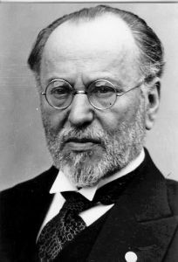
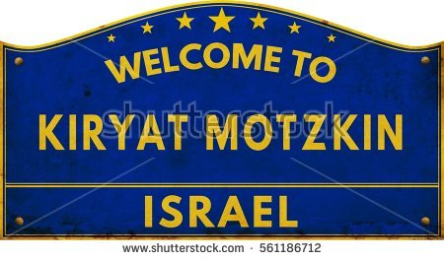

Nahum Sokolow:
Nahum Sokolow was born in Wyszogrod, Russian Poland in 1859 and received a traditional Jewish education. In secular subjects he was an autodidact specializing in languages and literature. He spoke German, French, Spanish and Italian as well as English, Yiddish, Hebrew, Polish and Russian. By profession he was a journalist writing for the Warsaw periodical HaTzefira. In time he became the owner and editor of the periodical. He wrote a number of books, one on Hebrew geography, another on anti-Semitism. In 1901 he wrote a tract in which he attempted to convince religious Jews that despite the secular leadership of the Zionist movement, there was no ideological reason for them to oppose the cause. Sokolow later translated Herzl's Altneuland into Hebrew giving it the title Tel-Aviv. In 1918 he wrote one of the earliest accounts of the history of Zionism controversially beginning his study in the mid-seventeenth century.

Sokolow was not a member of the Hovevei Zion movement even though his HaTzefira was Zionist in orientation. Indeed when Herzl's "The Jewish State" was published, Sokolow dismissed the Eretz-Israel option as an illusion. However, Sokolow went through a metamorphosis and rallied to the Zionist organization in particular after David Wolffsohn, Herzl's successor called on him to become the Secretary General of the World Zionist Organization. Sokolow held this position from 1907-1909 but differences over the political nature of Wolffsohn's Zionism led to a rift between the two men. In 1911, under a new administration, Sokolow became responsible for the political portfolio and tried to win support for the Zionist idea in particular in the United States and in Britain. Just before the outbreak of the First World War he had visited various Arab leaders but with the outbreak of hostilities he moved to England where he worked closely with Chaim Weizmann.

Sokolow became a key figure in the negotiations for the Balfour Declaration when he met with French officials and won a pro-Zionist statement from them in May 1917. He was received by Cardinal Gasparri, the Papal Secretary of State, who assured Sokolow that Zionism need not fear the Vatican. These missions elevated his status in the movement as evidenced by the fact that at the Paris Peace Conference in 1919 he headed the Zionist delegation. In 1921, Sokolow was elected Chairperson of the Zionist Executive during which time he traveled extensively, putting the case of the movement before various dignitaries including Mussolini. In 1931 following Weizmann's departure from the Presidency of the World Zionist Organization, Sokolow assumed his mantle although he continued the policies of his predecessor. When in 1935 Weizmann returned to the Presidency, Sokolow was elected honorary President and assumed responsibilities in the newly formed Cultural Department. He died in 1936. His remains were reinterred at Mt. Herzl, Jerusalem in 1956.

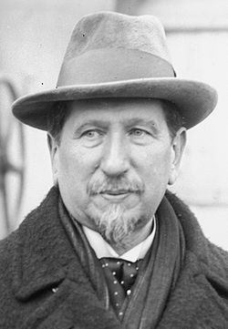
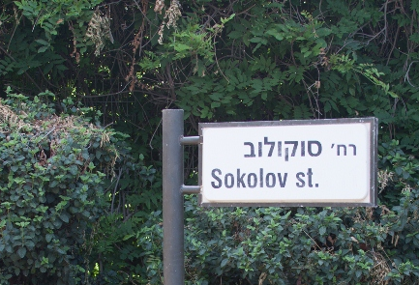

Chaim Weizmann:

Chaim Weizmann was born in Motol, Russia in 1874. He became active in the Zionist movement while studying in Geneva. In 1905 he moved to England, and was elected to the General Zionist Council.
Weizmann's scientific assistance to the Allied forces in World War I brought him into close contact with British leaders, enabling him to play a key role in the issuing of the Balfour Declaration on November 2, 1917, in which Britain committed itself to the establishment of a Jewish home in Palestine.
Weizmann led the Zionist delegation to the Peace Conference at Versailles, and in 1920 became the president of the World Zionist Organization (WZO). He headed the Jewish Agency which was established in 1929.
Chaim Weizmann again served as President of the WZO from 1935-1946. During the years that led up to World War II, he invested much effort in establishing the Jewish Brigade. He also tried, unsuccessfully, to prevent the issuing in 1939 of the White Paper, which in effect halted Jewish immigration to Palestine. During the Zionist Congress held in Geneva in August 1939, Weizmann harshly criticized the British government for its betrayal of the Mandate and the Jewish people.
On August 29, 1939, he wrote to British Prime Minister Neville Chamberlain to confirm previous declarations that the Jews stand by Great Britain and will fight on the side of the democracies…The Jewish Agency has recently had differences in the political field with the Mandatory Power. We would like these differences to give way before the greater and more pressing necessities of the time.
After World War II, Weizmann was instrumental in the adoption of the Partition Plan by the United Nations on November 29, 1947, and in the recognition of Israel by the United States.
With the declaration of the State of Israel, Weizmann was chosen to serve as the first President of Israel. This role he filled until his death in 1952.

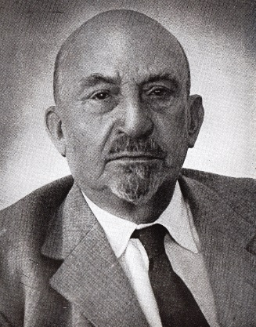
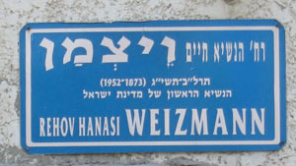

Altneuland:
Herzl lived to see 6 congresses, but his original idea, however, was not a popular movement. As a journalist and playwright, Herzl (1860-1904) first thought he could convince his people of the need for a national home by way of writing a novel about it. He did eventually write such a novel, Altneuland, but that was published only in 1902.
Altneuland – "Tel Aviv" in Hebrew, is Theodor Herzl's novel of the Zionist utopia that he wished to create in the land of Israel. In Altneuland, Herzl describes a modern, social-democratic pluralistic Jewish state in which Arabs and Jews have equal rights, and racist jingoistic sentiments are unpopular.
The illustration below is the frontispiece of Altneuland, published in Leipzig, Germany in 1902.

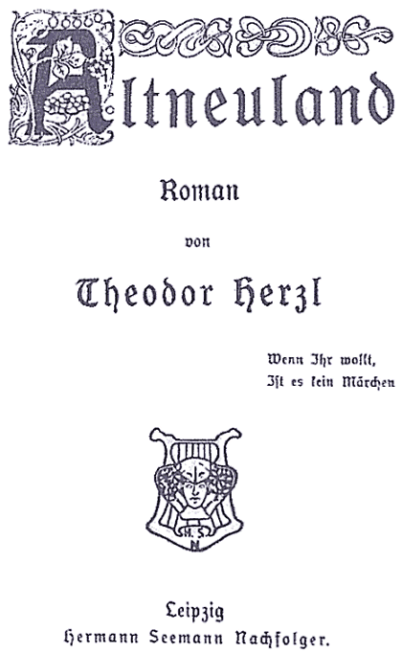

The next few selected quotes from the book, shows how Herzl has imagined the perfect Jewish land:
Work:
“Here, everyone has the right to work and therefore to bread”
“The wealth of a land is in its workers. Your own experience has taught you that. The more workers come, the more bread there is in a just society like ours”
“I would suggest a white flag with seven golden stars. The white symbolizes our pure new life; the stars the seven golden hours of our working day, for the Jews are going to the new land under the sign of work”

Socialism and welfare:
“Hospitals, infirmaries, orphan asylums, vacation camps, public kitchens-in short, all the types of benevolent institutions with which you were familiar have been merged here and placed under a unified administration. We are thus able to care for every sick and needy applicant. There are fewer demands on public charity here because conditions-I have the right to say so-are better on the whole…”
“The needy sick have only to apply to the public charities. No one is turned away: The various hospitals are connected with the charity headquarters by telephone”
Army service:
“All members of the New Society, men and women alike, are obligated to give two years to the service of the community. The usual thing is to give the two years between eighteen and twenty-after completing their studies”
Education system:
“I want to add, by the way, that education is free to the children of our members from the kindergarten through the university”
Co-existence:
“The Jews have enriched us. Why should we be angry with them? They dwell among us like brothers. Why should we not love them? I have never had a better friend among my co-religionists than David Littwak here. He may come to me, by day or night, and ask what he pleases. I shall give it him. And I know that I, too, may count upon him as upon a brother. He prays in a different house to the God who is above us all. But our houses of worship stand side by side, and I always believe that our prayers, when they rise, mingle somewhere up above, and then continue on their way together until they appear before Our Father”
Opinions on Herzl and Zionism:
The next few articles have been published in different online magazines. They are showing different sides to Herzl and Zionism and are a great trigger for our conversation:

Zionism Today: Where it succeeded, where it did not By Evyatar Friesel in Audiatur Online on 31.8.2017
Nevertheless, today, 120 years after the 1st. Zionisten-Congress, one is brought to recognize that there are major objectives of the original Zionist project that were not realized. True, in many aspects the State of Israel is a unique success story: modern, democratic, with a vibrant life, internationally recognized, with a self-sustaining economy and able to defend itself. The very fact that Jews from countries all over the world, culturally and socially deeply diverse, met and melted into a new and relatively well-functioning society is a feat that has no parallel.
However, the establishment of the Jewish state has created new problems, internal and external, that so far are without a solution, among them the relations between Israel and the Palestinians and the Moslems of the Middle East. A most perplexing question is the gap between the central aim of the 1897 Zionisten-Congress – to find a solution for the problem of modern antisemitism through the political normalization of the Jews -and the reality as it presents itself 120 years later. It is sadly obvious that Jewish statehood has not resolved the issue that moved Herzl and Political Zionism. Judeophobia continues to exist also in our days. We are forced to recognise today how deep the roots of Jew-hatred are in Western history and culture: neither the destruction of European Jewry in mid-twentieth century nor the establishment of Israel has brought about the hoped-for change in negative attitudes regarding Jews. Worse, presently it is the Jewish state, the most obvious expression of actual Jewish collective vitality that has become the major focus of Jew-hatred. Seventy years after the Shoah we hear again the intention to destroy millions of Jews, this time concentrated in Israel, and a significant segment of European society accepts such threats as a normal fact of life. Anti-Jewish expressions and tactics may have changed over the centuries, but its destructive aim remains the same.

How Herzl Sold Out the Armenians: (published May 1, 2015 by Rachel Elboim-Dror in Haaretz)
The Armenian question has occupied the Zionist movement since a mass killing of Armenians was carried out by the Turks in the mid-1890s – prior even to the First Zionist Congress. Herzl’s strategy was based on the idea of an exchange: The Jews would pay off the Ottoman Empire’s huge debt, in return for the acquisition of Palestine and the establishment of a Jewish state there, with the major powers’ consent. Herzl had been working hard to persuade Sultan Abdul Hamid II to accept the proposal, but to no avail. After much effort, he met with the Sultan on May 17, 1901.
The Sultan hoped that Herzl, a well-known journalist, would be able to alter the Ottoman Empire’s negative image. And so Herzl launched an intensive campaign to fulfill the Sultan’s wish, casting himself as a mediator for peace.
As was his way, he did not consult with other Zionist movement leaders, and kept his activities secret. But in need of some assistance, he wrote to Max Nordau to try to recruit him for the mission as well. Nordau responded with a one-word telegram: “No.” In his eagerness to obtain the charter for Palestine from the Turks, Herzl publicly declared – after the start of the yearly Zionist Congresses – that the Zionist movement expresses its admiration and gratitude to the Sultan, despite opposition from some representatives.
Herzl’s chief opponent on this was Bernard Lazare was so incensed by Herzl’s activity that he resigned from the Zionist Committee and abandoned the movement altogether in 1899. Lazare published an open letter to Herzl in which he asked: How can those who purport to represent the ancient people whose history is written in blood extend a welcoming hand to murderers, and no delegate to the Zionist Congress rises up in protest?
This drama involving Herzl – a leader who subordinated humanitarian considerations and served the Turkish authorities for the sake of the ideal of the Jewish state – is just one illustration of the frequent clash between political goals and moral principles. Israel has repeatedly been faced with such tragic dilemmas, as evidenced in more recent decisions that reflect the tension between humanitarian values and realpolitik considerations.
(The writer is professor emeritus of history of education and culture at Hebrew University.)

The Uganda Proposal: An Alternative History? Published on 16.1.2009 by DailyDrew
The Israeli incursion into Gaza bothers me dearly, as I know it does many Kossacks and much of the world. Arguments abound over culpability, but determining which side is (more) guilty is akin to the chicken and the egg paradox. But what if it never had to be? What if, not only the conflict, but the Holocaust could have been avoided as well? But, how? The answer lies in the oft forgotten Uganda Proposal which would have created a sanctuary for the Jewish people in the British controlled land. I would like to offer an extremely brief history of the proposal and discuss with all of you the impact of its rejection.
Theodor Herzl was the first leader of the Zionist movement, the goal of which was to establish a Jewish homeland in Palestine. The movement was catapulted by Dreyfus Affair (1894) which proved, to Herzl and others, that anti-Semitism was an ubiquitous force in Europe, and perhaps the world.
As leader of the Zionists, Herzl negotiated with British Government and came to an agreement to allow for the creation of a Jewish homeland in British controlled Uganda. The land was lush, with great biodiversity and fertile land. In 1903, Herzl proposed the agreement to the Sixth Zionist Congress, which decided to send a group to evaluate the territory. The relatively narrow margin by which the motion to send the expedition passed and the large number of abstentions, however, indicated the rift in the Zionist movement.
At the Seventh Zionist Congress in 1905, the proposal was rejected. Ironically, much of the resistance came from eastern European Jews, exactly those the proposed State was to protect. Most of the support came from western Europe. Although the land in Uganda was intended to be a temporary homeland for use until the Jews could claim Palestine which they viewed as their birthright, the opposition to the proposal was primarily that Palestine was the only acceptable place for a Jewish State.
In other words, the Zionists put ideology before safety and common sense. The few hundred amassed at the Zionist Congress condemned the many Jews in Europe to persecution and eventually genocide. They eschewed reason in the name of "purity". They allowed a fictionalized history determine the course of their peoples' lives.
I bring this topic up for a few reasons. First of all, I grew up in a Jewish household, although I abandoned the faith at a very early age. My mother, however insists on reminding me of my heritage in disturbing ways. Recently, she has been sending me pro-Israel propaganda that I would ordinarily characterize as right wing nonsense. These forwards are not only going into my inbox and it frightens me to think that the American Jewry may be in lock-step with the Israeli government, regardless of their aggression. The Uganda Proposal, to me is emblematic of myopic people who refuse to think critically. Of course, this description is not unique to Jews and applies to any fundamentalism, religious or otherwise.
The other motivating factor in bringing up this topic is to consider how the world would be different if the proposal had been accepted. Could the Ugandan homeland have been a refuge for Jews remaining in Europe in World War II? With a few decades to develop, could the State have been a military power with the ability to fight the Nazis? Would Hitler have even come to power? Of course these are questions no one can answer, but the fact that they could be raised is a condemnation of the kind of thought that went into rejecting the Uganda Proposal.

Questions for discussion-
- In the first congress it was established that "the aim of Zionism is to create for the Jewish people a home in Eretz Israel secured by law". Now that such a state exists, what should today’s definition of Zionism be?
- In Altneuland, Herzl describes a modern, social-democratic pluralistic Jewish state. Would he be happy to see Israel today?
- In his book Herzl described the importance of work. In today’s reality a lot of Hareidi people in Israel are not working. What would Herzl have to say about that?
- Was it realistic of Herzl to imagine a Jewish state where Arabs and Jews live together in coexistence?
- Evyatar Friesel says that “Anti-Jewish expressions and tactics may have changed over the centuries, but its destructive aim remains the same”. If that is the case, did Herzl achieve his goals?
- What do you think about Herzl’s strategy of working with people like the Turkish Sultan? Does the end justify the means?
- How would the world look today if the Uganda plan had been voted for?
- What – in your opinion – was the fundamental reason behind Herzl’s call for a Jewish State?

