Yad Sarah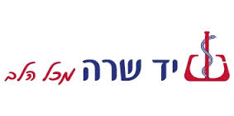

Yad Sarah, the largest voluntary organization in Israel. Yad Sarah serves over 350,000 clients each year. It is best known for its free loans of over 244,000 pieces of medical and rehabilitative home-care equipment annually enabling sick, disabled, elderly and recuperating patients to live at home.

It all began in the 1970s. A young Jerusalem high school teacher with a growing family needed to borrow a vaporizer from a neighbor for a sick child. Discovering that such appliances were hard to find, he bought a few to lend to others, and people started dropping off items they no longer needed.
The small apartment was soon overflowing with a variety of the kind of things people need for only a short time: crutches, walkers, vaporizers, even a couple of wheelchairs.
The teacher, Uri Lupolianski was mayor of Jerusalem from 2003 to 2008, saw there was a real need for this kind of help. Around that time, his father, the late Jacob Lupolianski, retired and sold his small shop. He offered to use the money to help. And so, in 1976, the Yad Sarah Organization was incorporated as a non-profit organization. It was named for Jacob`s mother, Sarah, who had perished in the Holocaust. The word "yad," which literally means "hand," is also used to mean a remembrance or a memorial.

Yad Sarah has been the recipient of several awards and citations, including the President`s Award for Volunteering in 1982 and the Kaplan Prize for Efficiency in 1990. In 1994, only 18 years after it was founded, Yad Sarah received the highest award given by the State of Israel: the Israel Prize, for "a significant contribution to the society and the State." In 2005, Yad Sarah was recognized as an advisory body to the Economic and Social Council (ECOSOC) of the United Nations -- the first time ever that an Israeli-Jewish organization achieved that status.

HaShomer HaChadash-
The new guard-השומר החדש
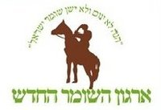
“He neither slumbers nor sleeps the Guardian of Israel “
“HaShomer HaChadash” is a young, grassroots volunteer organization established in 2007 to help farmers and ranchers in the Negev and the Galilee who administer vast tracts of state-owned land to deal with the threat of illegal seizure of their land. Like the original Guardsmen who protected remote Jewish village 100 years ago, HaShomer HaChadash works to ensure a stronger Jewish presence in the Negev and the Galilee and uphold the Zionist ideals on which the State of Israel was founded.
Since its inception, the number of HaShomer HaChadash volunteers has grown from 40 to thousands. The volunteer Guardsmen, who undergo intensive training, patrol the land from observation posts strategically set up by HaShomer HaChadash. Others volunteer to help the farmers and ranchers repair the damage caused by the marauders, and maintain their farms.
With insufficient manpower, local law enforcement is not equipped to deal with this problem. They cannot patrol the vast open lands and prevent the spread of fire, theft, physical violence and slaughtering of herds. HaShomer HaChadash is filling an essential need by creating a presence on the ground, thus discouraging the raiders.
Today, HaShomer HaChadash has over 700 committed volunteer guardsmen and thousands of agricultural volunteers who come to help in the Negev and the Galilee. HaShomer HaChadash is creating a new language of social action and inspiring a growing movement of young people to bring critical change to the State of Israel and to the Jewish people.

Their mission:
- To uphold the Zionist ideals on which the State of Israel was founded

- To help maintain Jewish land ownership in the open areas of the Galilee and the Negev

- To train a new cadre of young leaders who care about the State of Israel and will carry the Zionist dream forward

- To create a grassroots organization that promotes collective responsibility and citizen empowerment.
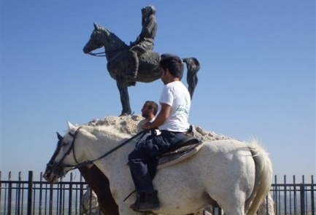
Stories:

- During his senior year in high school, Roi Hochman heard On Rifman speak. These 40 minutes changed his life. A few months later, Roi joined HaShomer HaChadash's Young Leadership Program; deferring his army service in order to give a year of volunteer service.

- Blond-hair, blue-eyed Ayelet Gordon is a tough woman. As one of Israel's only woman ranchers, she has raised three children alone, and struggled every day to maintain the precious herd of over 200 cattle on Kibbutz Yohanan in the Galilee.

- One night each month, from 10:00 pm – 5:00 am, Eti Or, 25, volunteers as a guardsmen with HaShomer HaChadash in the northern Negev. For Eti, it is the culmination of her desire to give back to help others, as she herself has been helped by so many to rise above her very difficult background.

Aharai! Follow me!

Aharai! is a social educational organization that develops young leadership and promotes social involvement among youths from the projects, development towns, absorption centers, boarding schools and shelters.
By connecting the youths to milestones in Israeli society; preparation for a significant military service in the IDF, preparation for the matriculation exams, immigrant integration programs, youth challenge programs, one year of community service, pre-military academy and alumni organization; the organization provides its youths a sense of achievement and capability and encourages them to fit in as contributing citizens in the State of Israel.
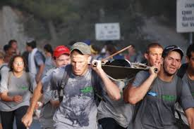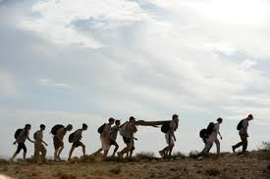
Guiding Values

- Personal and social responsibility-Achrayot eshiyt and chevratit
Reliability, commitment, initiative and formulation, cooperation, effort and investment, contributing to the community, giving, personal capability and responsibility.

- Human Dignity-Kvod HaAdam
Acceptance of others, the complexity of education, love of humanity, tolerance and democracy.

- Israeli identity-Zehot Israelit
Zionism, Judaism, military preparation, familiarity with the company, knowledge and love of country.

- Leadership-Manhigot
Initiative, transport, responsibility, caring, sensitive and social involvement.
- Expanding Horizons-Harchavat Ofakim
Education and curiosity.

Taubcenter-Merckaz Taub

For roughly four decades, Israel has been situated on a number of domestic socioeconomic trajectories that are unsustainable in the long-run. Israel’s education system consistently ranks near the bottom among Western countries, poverty rates are some of the highest in the developed world and the country is experiencing unparalleled rates of academic emigration. As one of Israel’s leading research institutes, the Taub Center offers independent, professional, evidence-based research findings and policy options to decision makers and the general public in order to address such challenges and support much-needed change in Israel’s social policy sphere.
The Taub Center was created in 1982, after Prime Minister Menachem Begin appointed Dr. Israel Katz (former Minister of Labor and Social Affairs) to head a new commission entitled the “Prime Minister’s Team for Planning Social Services.” This entity was charged with providing the government with innovative analyses, research and policy options.

The 2011 Israeli social justice protests

Since Operation Cast Lead,Israelhas seen a relative calm in its security situation. Up until that point, the security situation, for very good reasons, had monopolized the public agenda. This had left a gap of many decades in which internal security issues and social solidarity issues were insufficiently addressed, such as inadequate law enforcement, the issue of Jewish pluralism inIsrael(i.e. conversion), the decline of social solidarity, and the growing gap between the rich and poor, among others.
In the past year, theMediterraneanand Middle Eastern region has seen numerous uprisings, organized largely by the younger generation, and promoted by social media outlets like Facebook and Twitter. While many protests called for political revolution (EgyptandSyria), others called for economic and social change (likeGreeceandSpain). The above conditions have set a tone that is mirrored by the protests that have sprung up inIsraelover the last few months. In a quick review of these and other recent economic lurches around the world, one observes first the collapse of socialism as an effective and workable model for economic growth and human responsibility, and then the repeated cycle of boom and bust that seems to affect market capitalism. It is in light of this economic history that many countries have been seeking a mixed alternative.
In recent months, several protests about economic issues have sprung up inIsrael. Several leading protests have advocated for higher salaries for groups of professionals, such as the Social Workers’ Strike and the Doctors’ Strike. Other protests have focused on the high costs of living, particularly: the high prices of gas, the high prices of dairy products (the “cottage cheese protests”), the high cost of baby diapers, and so on.
Though all these protests communicated a frustration over the high cost of living in Israel, only one protest has reached the national level and evolved into one of the biggest social protests — if not the biggest — in Israel’s history: the “Tent Protest.” The Tent Protest began over the issues of high housing costs, as several young Tel Aviv residents set up a small tent camp in the center of Tel Aviv’s cultural-business district onRothschild Boulevard. Although it seemed obscure and disorganized at the beginning, the protest began to draw many young people who identified with the cause. In a matter of several days, the small tent camp on Rothschild grew and gathered momentum. The next week, the movement caught the attention of several student organizations and social activists, and similar tent camps popped up in towns acrossIsrael, each one representing the protester’s identification with both the national Tent movement, as well as their own additional local protests.
Initially dismissed as the passing whim of bored, young Tel Avivians, the Tent Protest has now escalated, with recent mass demonstrations counting close to 300,000 protestors in several locations across the country. These protests are characterized by a seemingly unfocused strategy, an absence of overt political affiliation, no clear leadership, and a multi-issue agenda with one unified slogan: “The people want social justice!” This movement has inspired the sense thatIsraelis at the brink of a significant shift in its social, economic, and cultural discourse.
It should be noted that the protests in Israelare characteristically non-violent and peaceful, in contrast with other recent protests around the world, such as the current protests in London typified by setting fires and rioting in the streets. It is also worth emphasizing how unprecedented it is for there to be such a huge and popular protest that deliberately does not define its aims according to traditional party-political lines. The feelings associated with the protests are very young, modern, and fluid – something not usually associated with Israeli struggles. Its organizers seem to strive (not always successfully, but increasingly so) to leave entry points open, to defy classification.
The protestors are characterized as typically middle- to upper-middle-class young professionals in their 20s and 30s, most with higher education, who range politically from centrist, to left of center, to radically left. It should be noted that this young generation was born and raised in a differentIsraelthan their parents: they have never experienced the welfare society and only know a free-market economy. As such, they have never experienced the frustrations that came along with such a highly centralized bureaucratic government or the reasons for which this system was abandoned. Perhaps because of this, the protestors often give voice to a romanticized interpretation of the early state years. On the other hand, these young protestors also experienced the ongoing growth of competition in the market and the abundance that flowed to Israeli consumers, allowing them higher standards of living. At the same time, these young people have been inspired by the power of a strong civil society and its potential to bring about social change.
Security politics has, for the most part, been removed from the dialogue, as protestors from both right and left join together to create change. Recent polls show that up to 87% of Israel’s public support this protest (including 85% of Likud [Binyamin Netanyahu’s political party] voters). Rothschild Boulevard has become a public attraction, with about 100,000 visitors each day going to check out what is going on.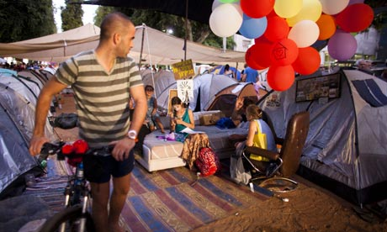

The Movement for Quality Government in Israel-HaTnu'a Lema'an Ekhut HaShilton BeYisrael
התנועה למען איכות השלטון בישראל‎
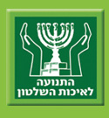
Is an Israeli non-profit organization that claims a membership of about 17,000. Formed as a protest movement in March 1990 during the coalition crisis, it is today the leading public petitioner to the Supreme Court of Israel.
The organization is influential in Israeli society and has had many favourable court rulings, some which had a decisive impact on Israeli politics. It has been at the forefront of various scandals and has been given considerable exposure in the Israeli media.

Tzimaon-Thirst
“In the summer of 2002 while in NY we went to see The Lion King on Broadway .When the show ended the actors went over seeking donations from the audience. They reminded us of the world outside, that there are those less fortunate that need the help of the more fortunate. They reminded us of home and a dream to make our home a better place.
One day in the middle of our life we gathered some friends and formed Tzimaon with Shlomo Artzi as Chairman, and decided to pick up slivers of forgotten dreams. We decided to rediscover Israel and rekindle the dream of a beautiful country.
We started in Givat Olga by renovating the Shahar youth club. A year later we went to the darker side of Tel Aviv to the Eitan Scouts troop in the Shapira neighborhood where we built a community center for the children and youths. We found students just before their big break into life and created a support system of scholarships and adopting families.
Over the years our vision became clearer, friends and supporters joined the cause, all as volunteers. We recognized that the choice we made was to invest in education. Realizing that the children and youth are the future of this country, they embody the promise for an enlightened, equal, just and better future we took it upon ourselves to improve and better the lives of the children in distressed neighborhoods and develop local leadership among the young residents. We encourage young people to dream and try to provide them with tools to bring them to a better starting point in life.”

First Aid Project
Tzimaon was formed out of a vision to combine resources, capabilities and good intentions of many people that could assist those less fortunate. At the beginning Tzimaon distributed food, cloths, furniture and medical equipment to people in need.

Over the years Tzimaon changed the concept of its work; it started focusing on long term educational projects with a variety of entities and other NPOs.

Nevertheless, we still dedicate a fraction of our budget to people in need which stories touch our hearts.
- Hearing aid for a gifted young girl;
- Installation of an AC system in a house of a sick infant;
- Special medical testing for children not insured by the state's healthcare system;
- Computer for a lone soldier;
- School bags;
- School books for three orphaned sisters;
- Special orthopedic shoes for a lone soldier;
- Refrigerator for a community center operated by volunteers for children from a distressed neighborhood;
- Psychological evaluation for a youth at risk;
- Television for a Leukemia girl in isolation;
- Laptop for a hospitalized cancer patient;

Scholarship to success project
The project focuses on young and older students. All of them have a tough life story, financially and emotionally. They all have the ability and desire to acquire a profession or an academic degree in order to sustain themselves with dignity.
After a process of sorting, interview and guidance in finding the right study framework, the student receives a financial and professional escort for the duration of his studies.
Tzimaon's support is provided only to students who are involved in community work and who are committed to continue their involvement after they complete their professional/academic training.
Every student has an accompanying "parent" that provides professional, personal and emotional support.
There are 12 students every year who study a variety of subjects. All the students work for a living.
Tzimaon has a moral obligation to support them in all aspects until they complete their studies/training.
Needless to say that acquiring a profession or an academic degree changes the life not only of the student but also the life of his family and their economic and social future.

Givat Olga
The connection between Tzimaon and the Givat Olga neighborhood of Hadera began in 2004.
We arrived there by chance, fell in love and stayed.
At first we were active in one street where we distributed food and cloths and renovated a youth club. As time went by we chose to focus on educational activities and took upon ourselves to enhance the cultural infrastructures in the neighborhood.
Together with other community entities and donors (Zionism 2000, Lautman Foundation) we support local youth clubs, youth movements, leadership courses, military orientation, and business entrepreneurship workshops to supplement families' income, educational sporting activities, music center and artistic activities, study groups in English and math where high school students tutor younger students, girls' club, parental guidance groups, life management groups and more.
A special "gem" in the neighborhood is the community library that provides a wide range of activities and is a "second home" for residents of all ages.
In addition to the financial resources we secure in order to support all the activities, there are many volunteers who donate their time, energy and capabilities to the various projects. All these enrich the diversified activities and enhance the bonds with the neighborhood's residents.
We recently initiated a new scholarship program in Givat Olga. The project is based on the unique concept developed by Tzimaon in which every student receives a scholarship for his studies and an accompanying "parent" (a volunteer) who supports him throughout the period of his studies. The students are committed to volunteer in one of the neighborhood's projects.

Kesher Yehudi-קשר יהודי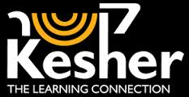

Kesher Yehudi is a non-profit organization, whose goal is to draw the different sectors of the Jewish People closer together by fostering personal friendships between secular and religious Jews and by providing opportunities for the study of Torah and various topics in Judaism in myriad ways.
Kesher Yehudi was founded in 2009 by Tzila Schneider, a 48-year-old religious mother of eleven who cared. After five years of activism as the manager of Project Chavruta – a program in which secular Jews were paired with religious ones to learn about Judaism together over the phone – she established Kesher Yehudi to target students and academics, offering them the opportunity to get to know chareidi society and Judaism "from the inside" by forming a close and personal relationship with young mitzvah-observant Jews.
"All of Klal Yisrael is responsible for one another," our Sages say. At Kesher Yehudi, we try to look beyond our own limited world.
We would all love to help create a unified Israeli society. Many of us, secular and religious alike, would like to get to know and understand one another better – but our daily lives are so busy that the opportunities to work toward this goal are few and far between.

Kesher Yehudi offers a number of programs for anyone interested in taking the first step and connecting to the concept: forming a relationship as a study partner via phone or email, attending chavruta events, hosting a secular guest in a chareidi neighborhood for Shabbos, integrated weekends for secular and religious people at a hotel, discussion groups on Facebook, and more.

A pair of friends at Kesher Yehudi
By the end of Kesher Yehudi's first year, nearly 4,000 participants had joined Kesher Yehudi's activism: approximately 1850 secular students and a similar number of religious men and women. 1500 participants have a chavruta relationship – once a week, they study together any topic related to Judaism. In addition, Kesher Yehudi has conducted six chavruta meetings between pre-military academies and students from yeshivos and religious high schools. Kesher Yehudi has also arranged five Shabbatot during which young, secular Jews spent Shabbat in religious neighborhoods in Jerusalem.
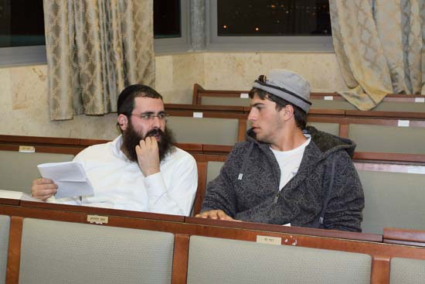
Ir Amim-עיר עמים
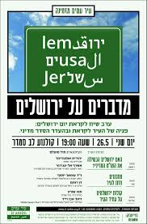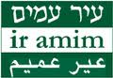
Ir Amim (“City of Nations” or “City of Peoples”) focuses on Jerusalem within the context of the Israeli-Palestinian conflict. Ir Amim seeks to render Jerusalem a more equitable and sustainable city for the Israelis and Palestinians who share it. Ir Amim envisions a city that ensures the dignity and welfare of all its residents and that safeguards their holy places, as well as their historical and cultural heritages -- today, as well as in the future. Ir Amim also aspires to a sustainable political future for Jerusalem, achievable only through a negotiated process between Israel and the Palestinians.
Ir Amim was founded in 2000, and became active as a non-profit organization in 2004.
In order to achieve its vision, Ir Amim uses the following three-pronged strategy:
1. Ongoing monitoring, policy and legal advoacy, and exposure of key developments in order to halt harmful government actions - that impede equitability, undermine Jerusalem’s stability, or threaten to derail negotiat-ions on final status issues (e.g. settlements, land expropriations).
2. Exposing the Israeli public and targeted groups to the realities and ramifications of current government policies in Jerusalem and re-orienting the public discourse on Jerusalem via study tours, media work, briefings, and educational programs.
3. Working together with a Palestinian NGO to design, propose and quietly catalyze several Palestinian socio-economic institutions in East Jerusalem. Ir Amim also works independently with Palestinian community-based civil society organizations, by providing capacity-building support and advice.
Ir Amim’s work in these fields has earned it a reputation as a reliable, dedicated and insightful organization – in the eyes of Israeli and international policy makers and opinion-shapers, and members of the Israeli public.
Machsom Watch
Who We Are:
MachsomWatch is a volunteer organization of Israeli women who are peace activists from all sectors of society. We oppose the Israeli occupation in the area known as the West Bank.
We support the right of Palestinians to move freely in their land and oppose the checkpoints which severely restrict Palestinian daily life.
Since 2001 we have been observing and reporting on the Occupation. On a daily basis we monitorthe West Bank checkpoints,the separation fences, the agricultural gates, the military courts and Palestinian villages. We document what we see and what is reported to us by local Palestinians.
Through our observations, reports, films, photographs and tours we aim to influence public opinion in Israel and throughout the world by recording and authenticating the impossible conditions faced by the Palestinians under Israeli occupation; conditionswhich also corrode the fabric of Israeli society and the values of democracy. We attempt to ease the frustrations and hardshipsof Palestinians by offering assistance wherever we can.
What We Do:
We conduct daily observations of Israel Defense Force checkpoints in the West Bank and the hamlets in the Jordan Valley, along the separation wall, along the seamline zone, on main as well as on bypass roads, and in military courts.
We monitor and report on the Civil Administration, the authority charged with all matters related to controlling the lives of Palestinians in the West Bank.
We document and photograph our observations and these reports are published on our MachsomWatch web site. Reports are also sent to public officials and elected representatives.
We attend and report on the proceedings in the military courts, the courts operated for the sole purpose of trying and sentencing Palestinians accused of various offenses and arrested by the Israel Defense Forces (IDF).
We try to help Palestinians who are blacklisted from entering Israel for any number of perceived offenses by trying to discover the exact reasons someone has been blacklisted.
We help Palestinians living in Seam Zone Villages who must apply for permits from the Civil Administration in order to conduct every aspect of their daily lives. Local village councils also receive guidance on how to deal with the Civil Administration.
We conduct educational activities with Palestinians looking to improve ways to deal with the lack of educational opportunities and facilities in the West Bank. MachsomWatch volunteers meet with and conduct social and educational activities for Palestinian women and children. These encounters are an opportunity for Palestinian women and children to meet Israelis without military presence.
We conduct tours in the West Bank and in the Jerusalem area to introduce Israelis and foreign guests to the reality of life under the Occupation.
We lecture and meet with foreign guests in Israel and abroad and share our experiences as activists against the Occupation and for Human Rights.
We produce documentary films about the Occupation which are screened in Israel and around the world.
We disseminate information to the media in order to focus attention on the realities of the Occupation.

Eretz shalom
Eretz Shalom is a social movement which works toward the advancement of peace and dialogue between the Jewish and Arab inhabitants of Judea and Samaria. The movement is mostly made up of sons of Abraham , Jews and Arabs who are interested in living in their homeland in mutual respect and cooperation with their neighbors. We understand that we are destined to be neighbors for many more years, it is in our interests and is, indeed, our mutual desire to advance good neighborly relations. Eretz Shalom is not a political movement and does not presume to offer conclusive solutions or to formulate peace agreements, but rather works from the participate in dialogue and joint projects in education, religion, culture and the environment in the hopes of creating change that will burgeon from the bottom up.

“It is obvious to all how the concept of ownership in regard to the land leads to many of the conflicts and even wars. Concepts of ownership and possessions in regard to the land are not only dangerous but also very far from what Judaism teaches, an example of this would be the laws of the sabbatical year where the land stays barren and ‘returns’ to it’s creator. We follow the scripture’s statement that “to myself is all the land”, meaning that only G-d owns the land and all humans are just temporary inhabitants. If in the first generation of the settlement movement the motto was “The land of Israel belong to the people of Israel”, we who follow the teachings of Rabbi Froman claim that “The people of Israel belong to the Land of Israel”, meaning we belong here and we love the land that we live on. This approach of belonging is a much more modest and less forceful approach towards the land. This seemingly semantic change can alter the type of dialogue and the language used in it.”

Ha’emek- pre army academy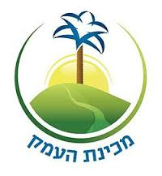

Located in the village of Tel HaTeumim in the beautiful and pastoral Beit Shean Valley (just south of the Sea of Galilee), Mechinat HaEmek enables you to become a part of a community of religious and secular Jews, for an unforgettable experience in which you’ll gain valuable leadership skills and explore your Jewish identity. HaEmek is a year of service and study, during which you’ll get a chance to leave a lasting impact on Israeli society, through volunteering in the communities of the Beit Shean Valley, and on the land of Israel, by helping to build “The Valley Trail,” and undergoing a training course to become a certified Valley Trail guide. You’ll be exposed to worlds of knowledge and culture that will enable you to build bridges between different sectors of the Jewish people and beyond.
Study
Learning in Mechinat HaEmek doesn’t just take place in the classroom, but also between classes, outdoors in nature, on trips and in volunteering locations in the community. The study is meant to shape both life within the Mechina, and guide students after they have graduated. Among the subjects taught by HaEmek’s highly-qualified teaching staff are post-biblical Jewish literature, Torah study, Jewish philosophy, social justice, and Zionist philosophy.

Social Action:
Mechinat HaEmek students are at the forefront of social change in the city of Beit She’an and the communities around the Beit She’an valley. The volunteer work is done in full cooperation with the public education system and welfare institutions in the communities where the Mechina is located. Mechina students are active in three main tracks: (1) Work with children within the formal education system; (2) community initiatives with youth in informal educational settings, with an emphasis on communal empowerment; and (3) work with senior citizens at day centers and with disabled residents of the area.
HaEmek trains its students to be social entrepreneurs in their community, through a social entrepreneurship course and field experience, with students putting their ideas into action in the community to empower the children and youth of the Beit Shean Valley.
Explore:
Students of Mechinat HaEmek also get the chance to explore Israel in week-long in-depth seminars around Israel and nature excursions. Mechinat HaEmek students work on building the “Shvil HaEmek” (valley trail), and undergo training to become certified guides on the Shvil HaEmek.
Throughout the year, week-long seminars break up the routine to focus on a variety of different subjects, such as a Jerusalem seminar, seminars in the south and north of Israel, a nature “field” seminar, and more. HaEmek also pioneered the “society” seminar, during which students are split into small groups, and each group is sent off to spend a week in a different sector of Israeli society.
Ma'aglei Tzedek ("Paths of Righteousness") merges social activism with education in an effort to fix social ills. We provide educational programs that combine action and study, and which are informed and inspired by Jewish values. Our goal is to motivate broader participation in efforts to achieve a more just society.Ma'aglei Tzedek was established in 2004 by a group of young social activists who strongly believed that Jewish sources could inspire greater commitment to social justice. Since then, the organization has grown to include hundreds of volunteers and activists.
We engage Israelis, religious and secular, in both formal and informal educational settings, such as high schools, youth movements, universities, and the army.We belive that anyone can act to make the world a better place.
Our ongoing projects
- The Tav Chevrati, a certificate granted to restaurants that are accessible to people with disabilities and treat their workers ethically
- "Employment Watchdogs," whereby high school students advocate on behalf of non-union custodial workers working in their schools
- Legislation advocacy, including preparation of background research to support improved legislation for social justice

Ayalim Association
The Ayalim Association was founded in 2002 with the goal of strengthening existing communities and social involvement in the Negev and Galilee
The establishment of Student Villages constitutes the foundation for social involvement and the creation of new permanent communities. The students in our villages integrate community building and social outreach, thereby promoting society and education in the Negev and Galilee. In return for academic scholarships and subsidized housing in the villages, each student in Ayalim volunteers with children in development towns and distressed neighborhoods, and takes part in the association’s special projects, with the understanding that the projects’ success depends on the fusion of individual needs with national objectives.
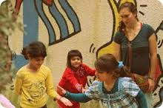
Hod-הוד
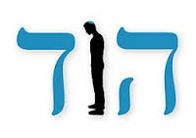

HOD is the first independent website that was written by Orthodox Jewish gay men, for Orthodox Jewish gay men and that is not affiliated with any organization or political movement. We are pioneers who are walking an unpaved path, who are part of the religious community, and who wish to remain part of it. We do not give up on our religious identity, nor do we wish to abandon our homosexual identity. We hope that this site will offer a glance at the world of religious homosexuals and that it will lead to a more tolerant dialogue in our society.
We want to initiate a public dialogue in the religious community, among its leaders, its rabbis, encompassing both the Halachic and social scopes, in order to obtain recognition of religious gay men as a part of the religious community which cannot be neglected anymore. A dialogue that would lead to an improvement of the social situation of the religious homosexual man, within the religious society.

