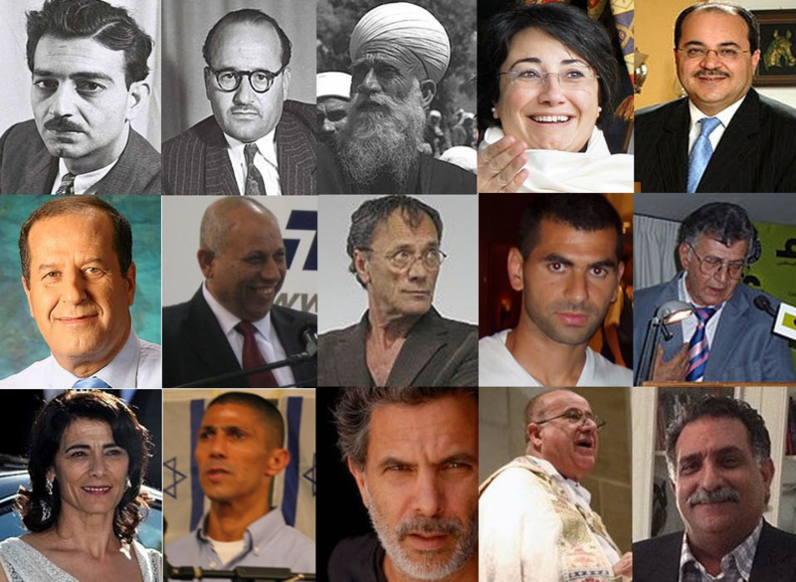

Arab citizens of Israel
عرب إسرائيل (العرب الإسرائيليون)‏
ערבים אזרחי ישראל

Arab citizens of Israel are non-Jewish Israeli citizens who were residents of Mandatory Palestine and remained within Israel's borders following the 1948 Arab-Israeli War, and the establishment of the state of Israel. It is including those born within the state borders subsequent to this time, as well as those who had left during the exodus (or their descendants), who have since re-entered by means accepted as lawful residence by the Israeli state (primarily family reunifications).
The relationship of Arab citizens to the State of Israel is often fraught with tension and can be regarded in the context of relations between minority populations and state authorities elsewhere in the world. The tension between their Palestinian Arab national identity and their identity as citizens of Israel was famously described by an Arab public figure as: "My state is at war with my nation"
- Total population: 1,658,000: Over 278,000 in East Jerusalem and the Golan Heights (2013). *20.7% of Israeli population *
- Religion : Islam 83.8% (mostly Sunni), Christianity 8.4% and Druze8.2%
- Representation in the Knesset: 10% of the Israeli parliament
- Arabic is one of Israel's official languages

