12/19/2013
Tu BeeShvat program – Making a grass head
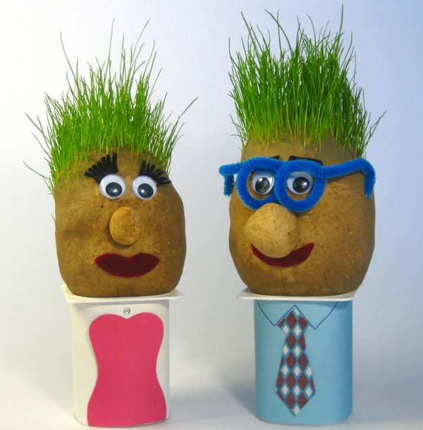
Grass Heads are super easy (and fun) to make, and make great homemade gifts for kids. Kids especially love trimming the "hair". It can be easily be connected to the Jewish holiday of Tu BeeShvat.

You will need:
- Old nylon stockings or pantyhose. Knee highs and pop socks, work great. You can also use regular old socks, but the grass sometimes has trouble poking through.
- Grass seeds. A small "lawn repair kit" which has seeds pre-mixed with slow release fertilizer, but you can use whatever seeds you've got handy.
- Sawdust or potting mix for stuffing. Or just some soil from your garden.
- Small yoghurt pot / plastic bottle.
- Decorations. Goggly eyes and fabric scraps for the heads, colored paper for the bodies, pipe-cleaners for spectacles.
- Water-proof glue. For sticking on the eyes, lips, etc.

How to –
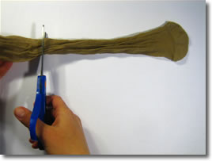
Step 1: Cut off an 8" (20cm) section of stocking that includes the toe. (You could also use a "tube section" that doesn't include the toe - you'd just have to tie a knot in one end to close it, then turn it inside-out to hide the knot).

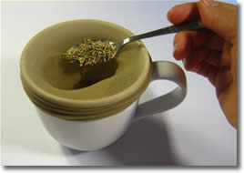
Step 2: Stretch the stocking over a large cup or mug, and spoon in about 2 teaspoons full of grass seeds.

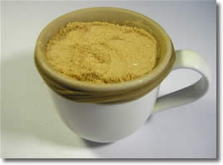
Step 3: Pack in some sawdust or potting soil. Aim for the head to be roughly tennis ball sized.

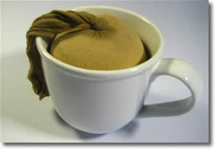
Step 4: Tie a knot to close the end. No need to cut off the dangly bit.

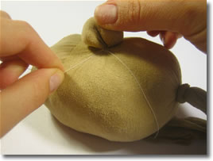
Step 5: You can make a bulbous nose or ears by grabbing a bit of stocking and twisting. Fasten base of the nose with some thread or a small rubber band.

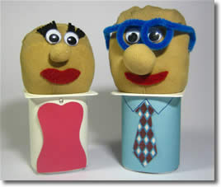
Step 6: Decorate! Use fabric scraps or permanent marker to decorate the face, and coloured paper to make the yoghurt container into a dress or a suit or whatever you like - get creative! Just make sure that any glues or markers you use for the head are water-proof.

Happy Tu BeeShvat !

