Decomposing of materials in nature
Opening remarks: The teacher will start by asking the students what are the materials that mankind is throwing to waste? What kind of materials decompose fast? What decompose slowly?
Main program:
- The teacher will divide the students to 2-4 groups (according to the number of participants).
- Each group will get 2 sets of prints – one print of pictures and one of numbers (appendix 1).
- All groups will have 4-6 minutes to decide as a group what number (of years) goes with each picture.
- When the time runs out the teacher will go over the correct answers and reward the wining group.
Information chart:
Material | Time of Decomposing  (Years)
Leather | 50
Organic waste | 1 month
Paper and cardboard | 3 months
Cotton fabric | 6 months
Wool | 1
Wood | 50
Tin | 100
Aluminum | 400
Plastic and nylon | 200
Diaper | 500
Glass | 1,000,000
Styrofoam | Never
Rubber tire | Never
Cigarette | 15
At the end of the program think about presenting the students the short video clip about “Hirya” the waste site that was transformed to a park and educational recycling center.
http://www.youtube.com/watch?v=deA8021hLXg
Appendix 1
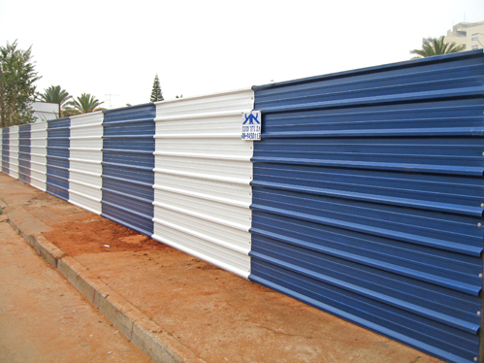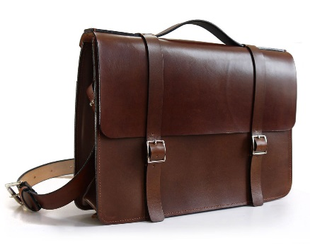
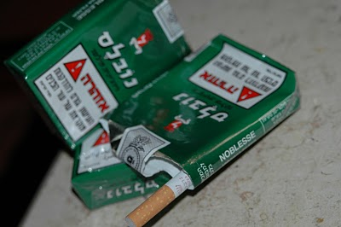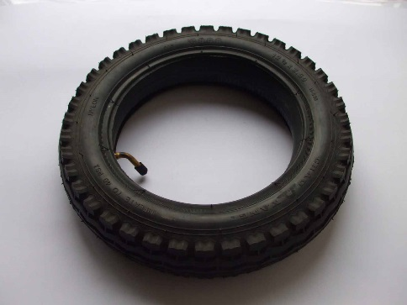

Tip: write at the other side of each picture the name of the material.

