Snake quiz / fifth - sixth grade

Goal: knowing basic concepts in “Chodesh Elul” “Codesh Tishray” holydays and “Rosh Hashna” special meaning.

Snake game board divided to numbers. The group splits in two-three small teams. Each team gets its own pawn The “Madrich/a” will get the questions written on cards. Each team will choose a representative (this will be a competition so it is better to notify the kids about it’ so they could choose the fastest “chanich” as their representative), his job is to run and deliver the questions to his team each time. The three representatives will get the first question at the same time and run to their team. Together the team will try to find out what is the answer, and when they come to conclusion, the runner will run as fast as he can, and whisper the answer to the “madrich/a”. If the answer is correct the “madrich/a “ will give him the next question and will move the pawn one spot ahead.
The first team that will reach to the end of the snake will be the WINNER.

answers | questions
"אני לדודי ודודי לי" "Ani Ledudi Ududi Li" | 1. What are the initials of "ELUL"?
"אבינו מלכנו" Avino Malkeno” " | 2. Special prayer where we ask for forgiveness
Rain | 3. We ask for it at "Shmini-Atzeret
Decree | 4. Repentant , Tefila and zedaka transfer it-
"הקפות" “Hakafot” | 5. 7 rounds around the shall- stage on "Simchat Tora”-
“Hoshana-Rabba” | 6. The sixth day of Sukut"-
"וידוי" “Vidoi” | 7. Said in "Yom-Kippur” ten times
“Sefer – Yona” "ספר יונה" | 8. A book that is read at the "Haftara” on “yom-Kippur”
“Moshiv Haroch u’Morid -Ha’Gashem  ”"מושיב הרוח ומוריד הגשם” | 9. Instead of "Morid Hatal” we say-
“Tefilat Ne’ila”  "תפילת נעילה" | 10. The pray that end "Yom-Kippur”
White wear | 11. What do we use to wear on "Yom-Kippur”?
“Beit- Hamikdash” “בית המקדש” | 12. The place where "Am-Israel” went 3 times a year?
“כפרות" “Kaparot” | 13. A substitute for one person’s sins (chicken…)?
Leather shoes | 14. We shouldn't wear them during "Yom-Kippur”
" "תשליך" Tashlich” | 15. A custom that has to do with our cloth pockets on “Rosh-Ha’shana”-

After the game the madrich/a will say that in our game we run and tried to get as much correct answers as we can. That’s how life usually is. Always running, chasing success, chasing money etc. But before “Rosh Hashana” we have to stop and start looking at our actions, find our bad actions and try and hope to improve them. after we done all this than we can make a decision for next year.

Snake quiz / fourth grade

Goal: knowing basic concepts in “Chodesh Elul” “Codesh Tishray” holydays and “Rosh Hashna” special meaning.

Snake game board divided to numbers. The group splits in two-three small teams. Each team gets its own pawn . The “Madrich/a” will get the questions written on cards. Each team will choose a representative (this will be a competition so it is better to notify the kids about it’ so they could choose the fastest “chanich” as their representative), his job is to run and deliver the questions to his team each time. The three representatives will get the first question at the same time and run to their team. Together the team will try to find out what is the answer, and when they come to conclusion, the runner will run as fast as he can, and whisper the answer to the “madrich/a”. If the answer is correct the “madrich/a “ will give him the next question and will move the pawn
The first team that will reach to the end of the snake will be the WINNER.

answers | questions
Fish | 1. Its head is eaten on rosh hashana eve.
Honey | 2. We deep apple in it.
Rain | 3. We ask for it at "Shmini-Atzeret
“Chol Hmoed” | 4. Six days during "sukot"
"הקפות" “Hakafot” | 5. 7 rounds around the shall- stage on "Simchat Tora”-
“Hoshana-Rabba” | 6. The sixth day of Sukut"-
Vdodi li | 7. ani ldodi…
Holidays | 8. Four of them take place at “Chodesh Elul”
“Moshiv Haroch u’Morid -Ha’Gashem  ”"מושיב הרוח ומוריד הגשם” | 9. Instead of "Morid Hatal” we say-
“Tefilat Ne’ila”  "תפילת נעילה" | 10. The pray that end "Yom-Kippur”
White wear | 11. What do we use to wear on "Yom-Kippur”?
“Beit- Hamikdash” “בית המקדש” | 12. The place where "Am-Israel” went 3 times a year?
“Slichot” | 13. A special “Tefila” said during “Codesh Elul”
Leather shoes | 14. We shouldn't wear them during "Yom-Kippur”
" "תשליך" Tashlich” | 15. A custom that has to do with our cloth pockets on “Rosh-Ha’shana”-

After the game the madrich/a will say that in our game we run and tried to get as much correct answers as we can. That’s how life usually is. Always running, chasing success, chasing money etc. But before “Rosh Hashana” we have to stop and start looking at our actions, find our bad actions and try and hope to improve them. after we done all this than we can make a decision for next year.

Questions
- Which month is the “rachamim and the slichot month”?
  - Elul ✓
  - Tishrey
  - Av
- Why are we having fish for “Rosh Hashana”?
  - Because it’s a bless for us to be as many as there are fish in the sea.
  - Because it’s a bless for us to be a head and not a tail.
  - A + B ✓
- What is the first step in the way for “Tshuva”?
  - Confessing
  - Regret
  - Recognizing the sin ✓
- When do the “sfaradim” starts saying “slichot”?
  - 40 days before “Rosh Hashana”
  - On the week of “Rosh Hashana”
  - On “Rosh Chodesh Elul” ✓
- Why are we having “Rimon” for “Rosh Hashana”?
  - So our privileges we’ll be as many as the rimon seeds ✓
  - Because it’s the season fruit
  - So we’ll have a sweet year.
- When are we starting to blow the “shofar”
  - On “Rosh Hashana” eve only
  - On “Rosh Chodesh Elul” ✓
  - On the week of “Rosh Hashana”
- The theme of our peulla is going to be about –
  - “Chodesh Tishrey”
  - Blowing the shofar
  - “Heshbon Nefesh” ✓

Woodside Park Youth

A Young Persons Guide to
Rosh Hashana 5767


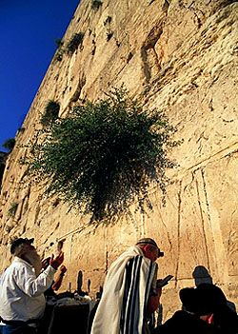

Please don’t throw this away, or take it home on Shabbat.

Also, if you’ve finished with it, please return it,
so that other people can read it too!

Shana Tova – Happy new year!!

Firstly, I would like to welcome everyone to shul this Rosh Hashana.

Although this Yom Tov isn’t filled with so many fun things to do like shaking some leaves or lighting a Menorah and getting presents – there is still a lot to learn about and good fun to be had over the two days of Yom Tov.

The services over Rosh Hashana are very long – that’s because we pray extra hard at this time of year so that we and the whole Jewish people can have a good year next year.
Just in case the long services get a bit much, here are some things to read and do over Yom Tov.

I hope that all of you will have a meaningful few days and that all your prayers will be answered!

See you all at the youth services!!

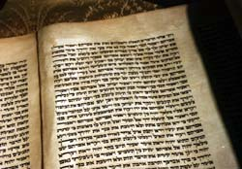
David Vincent
Youth co-ordinator

The month of Tishrei (around September and/or October) is the busiest time of the year for Jewish holidays. In the month of Tishrei, there are a total of 12 days of Chag (or Yom Tov), 7 of them Chaggim on which Melacha (work) is not permitted.

These Chaggim include the days known as the "Yomim Noraim," (High Holydays), the most important holidays of the Jewish year: Rosh Hashana and Yom Kippur. Four days after Yom Kippur comes the Chag of Sukkot.

Rosh Hashanah - the New Year, and Yom Kippur - the day of atonement, are two very important holidays in the Jewish calendar.
On Rosh Hashanah, Jews all over the world gather in synagogues to celebrate the day Hashem created Adam and Chava (Eve), the first humans.

We celebrate Rosh Hashanah with sweet foods, like apples dipped in honey and honey cake, as a wish for a sweet year. Some families also celebrate with symbolic foods like the head of a fish, pomegranates, and carrots.
The head of a fish is so that we can be "like the head and not like the tail." This is a symbol of having a year in which we are on top and not the bottom. Pomegranates are symbolic of plenty. Have you ever tried to count how many seeds there are in a pomegranate? Far too many to count. We want plenty of health and happiness for the New Year, just as many good things as there are seed in a pomegranate.
We also eat carrots, and it isn't just to see better in the dark. For Ashkenazi Jews, carrots symbolize the Yiddish word "merren" which also means more. We want more of all the good things in life. More health, more happiness, more success. For Sephardic Jews, carrots are symbolic of the phrase "Yikaretu oyveychem" which means may your enemies be cut down. We ask that those who wish bad for us not get their wish, that they don't succeed.
And of course, we have round Challot made with honey and raisins. These are another symbol of a sweet and happy year.
Rosh Hashanah starts on the first day of Tishrei and lasts two days. Rosh Hashanah is the beginning of the Yamim Noraim, the ten days of atonement.
On Rosh Hashanah, all mankind is judged. Hashem writes the judgment for each of us in the Book of Life. This judgment is based on our lives of the year before, and is the decision of what will happen to us in the coming year.
But the judgment is not final. The days between Rosh Hashanah and Yom Kippur give us a time to change the judgment for good. We are given the chance to improve our coming year through Teshuvah (asking forgiveness), Tefillah (prayer), and Tzedakah (charity).
On Rosh Hashanah we wish each other "L'Shanah Tovah Tikatevuh" may you be written in for a good year. But Rosh HaShanah is not the end of the judgment, it is only on Yom Kippur that our judgment is made final

Tzedaka (charity)
The Mishneh Torah of Moses Maimonides states that there are eight different levels of Tzedaka
1. The Person who gives reluctantly and with regret.
2. The person who gives graciously, but less than one should.
3. The person who gives what one should, but only after being asked.
4. The person who gives before being asked.
5. The person who gives without knowing to whom one gives, although the recipient knows the identity of the donor.
6. The person who gives without making one's identity known.
7. The person who gives without knowing to whom one gives and the recipient does not know from whom he receives.
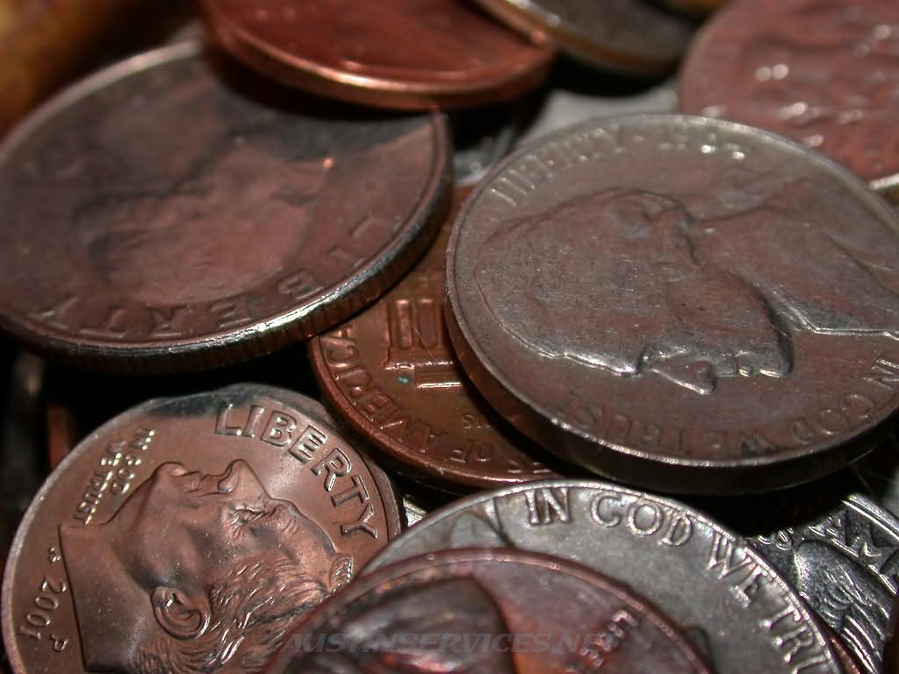
8. The person who helps another to support oneself by a gift or loan or by finding employment for that person, thus helping that person become self-supporting

Prayer V Common Sense

Ben Cohen is a devoutly religious man who believes in the power of prayer. His house is caught in the rising waters of a devastating flood. A boat comes by to rescue him, but he refuses it because he waits for his G-d to save him.

As the waters rise, Ben climbs higher and higher up his house, refusing each successive boat that comes by. Finally he drowns and goes to heaven. He complains bitterly to G-d that he was such a good Jew and yet the Lord had ignored him!
"How can you say that?" G-d retorts. "I sent four boats for you!"
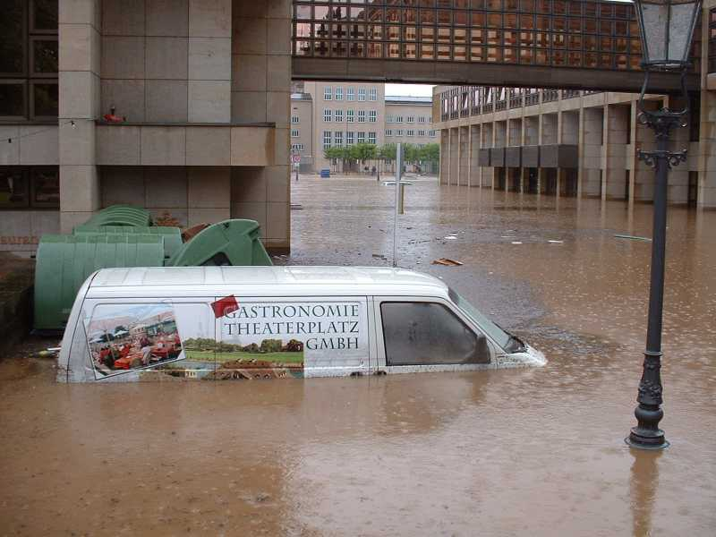

this Rosh Hashana?
You’re only 10 questions away…

 | Why do we eat a lot of honey on Rosh Hashanah? | It tastes good
 | Why do we eat a lot of honey on Rosh Hashanah? | We hope that Hashem will grant us a sweet new year.
 | Why do we eat a lot of honey on Rosh Hashanah? | It goes nicely with apples
 | Why do we eat a lot of honey on Rosh Hashanah? | We should be as busy as bees during the upcoming year.
 | What is the ceremony called where we cast off our sins into the water? | Sukkot
 |  | Shimini Atzeret
 |  | Tashlich
 |  | Mikva
 | There are two blessings before sounding the Shofar, one is thanking Hashem for commanding us, what is the other? | Shehechianu
 |  | Bracha
 |  | Machzor
 |  | There is only one blessing
 | On Rosh Hashanah we are given a chance to improve for the next year by doing three things. What are they? | Teshuva, Tefillah, Tzadaka
 |  | Mitzva, Shabbat, and kindness
 |  | Kashrut, Shabbat, Honesty
 |  | None of the above
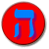 | Which book of the Bible does the Tashlich prayer come from? | Joshua
 | Which book of the Bible does the Tashlich prayer come from? | Ezekiel
 | Which book of the Bible does the Tashlich prayer come from? | Amos
 | Which book of the Bible does the Tashlich prayer come from? | Micha
 | Rosh Hashanah is the beginning of the Ten Days of Repentance known as: | Aseret Yemay Teshuva
 |  | The Fast of Gedaliah
 |  | Yom Kippur
 |  | Yom Hadin
 | Rosh Hashanah is also known as the Day of Judgment. What is it in Hebrew? | Yom HaZikaron
 |  | Yom Machzor
 |  | Yom Hadin
 |  | Yom Truah
 | Rosh Hashanah is also known as the Day of Remembering. What is it in Hebrew? | Yom HaZikaron
 |  | Yom Machzor
 |  | Yom Hadin
 |  | Yom Truah
 | Rosh Hashanah is also known as the Day of blowing the shofar. What is it in Hebrew? | Yom HaZikaron
 |  | Yom Machzor
 |  | Yom Hadin
 |  | Yom Truah
 | What is the name of the prayer book we use during the high holidays? | Machzor
 |  | Shofar
 |  | Siddur
 |  | Haggada

The Shofar
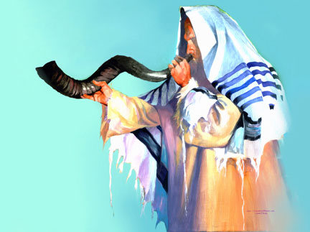

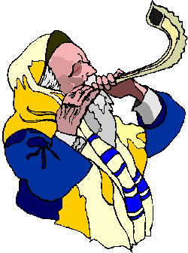
The shofar (ram's horn), is blown on Rosh Hashana. It sounds something like a trumpet. However, unlike a trumpet, the shofar has no mouthpiece. One of the most important Mitzvot of this Chag is hearing the 100 sounds coming from the shofar in the synagogue each day of Rosh Hashana (except for Shabbat this year, because we don’t blow the Shofar on Shabbat).

There are three different types of shofar sounds:
Tekiah, a 3 second sustained note;

Shevarim, three 1-second notes rising in tone,

Teruah, a series of short notes extending over a period of about 3 seconds;

There is also a Tekiah Gedolah (literally, "big Tekiah"), the final blast, which lasts longer than the regular Tekiah.

It is very difficult to blow the shofar. A Ba'al tokay-ah, (Shofar blower) may spend many hours practicing before Rosh Hashana.

The Ba'al tokay-ah should be someone who is respected in the community, a person who is well liked and does good deeds. Another person stands next to the Ba'al tokay-ah, and calls out the order of the Tekiyot. You are supposed to stand during the Tekiyot, but more important, it is forbidden to talk from the time of the first Bracha (blessing) of the shofar until after the final shofar blasts at the end of Mussaf.

The Torah gives no specific reason why we blow the shofar on Rosh Hashana. According to the great Jewish scholar, Rambam (Maimondies), we blow the shofar on Rosh Hashana to say, "Wake up! Wake up, everyone who is asleep! Remember your Creator! Instead of going around doing things that are not important or worthwhile, take some time to think about what you can do to make yourself into a better person. Give up doing bad things!"
Rav Saadia Gaon gave many reasons for blowing the shofar, here are some:

- Rosh Hashana is the birthday of the world.

- The shofar reminds us of Akeidat Yitzchak, (the Binding of Isaac) where Abraham sacrificed a ram in the place of his son.

- At Har (Mount) Sinai, when Hashem gave us the Torah, Bnei Yisroel heard the sound of a shofar. The shofar reminds us that Hashem gave us laws and rules to obey.

- The shofar is the call of redemption. The shofar reminds us that Hashem will redeem the Jewish people.

- The shofar is not blown if Rosh Hashana falls on a Shabbat (like this year – Sorry!!)

THE TEKIAH SOUND
Rosh Hashana is the day of appreciating who G-d is. We then internalize that understanding so that it becomes a living, practical part of our everyday reality. G-d is all-powerful. G-d is the Creator. G-d is the Sustainer. G-d is the Supervisor. In short, G-d is King of the Universe.
But for many of us, the idea of a "king" conjures up images of a greedy and power-hungry despot who wants to subjugate the masses for his selfish aims.
In Jewish tradition, a king is first and foremost a servant of the people. His only concern is that the people live in happiness and harmony. His decrees and laws are only for the good of the people, not for himself.
The object of Rosh Hashana is to crown G-d as our King. Tekiah -- the long, straight shofar blast -- is the sound of the King's coronation. In the Garden of Eden, Adam's first act was to proclaim G-d as King. And now, the shofar proclaims to ourselves and to the world: G-d is our King. We set our values straight and return to the reality of G-d as the One Who runs the world... guiding history, moving mountains, and caring for each and every human being individually and personally.
Maimonides adds one important qualification: It isn't enough that G-d is MY King alone. If ALL humanity doesn't recognize G-d as King, then there is something lacking in my own relationship with G-d. Part of my love for the Almighty is to help guide all people to an appreciation of Him. Of course this is largely an expression of my deep caring for others. But it also affects my own sense of G-d's all-encompassing Kingship.
THE SHEVARIM SOUND
When we think about the year gone by, we know deep down that we've failed to live up to our full potential. In the coming year, we yearn not to waste that opportunity ever again. The Kabbalists say that Shevarim -- three medium, wailing blasts -- is the sobbing cry of a Jewish heart -- yearning to connect, to grow, to achieve.
Every person has the ability to change and be great. This can be accomplished much faster than you ever dreamed of. The key is to pray from the bottom of your heart and ask G-d for the ability to become great. Don't let yourself be constrained by the past. You know you have enormous potential.
At the moment the shofar is blown, we cry out to G-d from the depths of our soul. This is the moment -- when our souls stand before the Almighty without any barriers -- that we can truly let go.
THE TERUAH SOUND
On Rosh Hashana, we need to wake up and be honest and objective about our lives: Who we are, where we've been, and which direction we're headed. The Teruah sound -- 9 quick blasts in short succession -- resembles an alarm clock, arousing us from our spiritual slumber. The shofar brings clarity, alertness, and focus.
The Talmud says: "When there's judgement from below, there's no need for judgement from above." What this means is that if we take the time to construct a sincere, realistic model of how we've fallen short in the past, and what we expect to change in the future, then G-d doesn't need to "wake us up" to what we already know.
G-d wants us to make an honest effort to maximize the gifts He gave us. You aren't expected to be anything you're not. But you can't hoodwink G-d, either.
The reason we lose touch and make mistakes is because we don't take the time everyday to reconnect with our deepest desires and essence. The solution is to spend time alone everyday, asking: Am I on track? Am I focused? Am I pursuing goals which will make the greatest overall difference in my life and in the world?
Make it a habit to keep in touch with yourself, and when Rosh Hashana comes around, the alarm clock of the shofar won't be nearly as jarring!

"You will cast all your sins into the depths of the sea." (Micah 7:19)



On the afternoon of the first day of Rosh Hashanah it is traditional to walk to a river or spring (preferably one that has fish in it) and recite special prayers called penitential prayers. The Tashlich prayer comes from the Book of Micha (7:18-20) in the TaNaCH (Torah Nevi’im and Ketuvim – The Bible). After you say the prayers you throw the bread crumbs into the water.
Some people keep a piece of the Afikoman from Pesach for this purpose to link the holidays together.
Tossing the bread crumbs on the water is symbolic of casting away our sins and starting a new year with a clean slate.

If the first day of Rosh Hashanah falls on Shabbat then Tashlich is traditionally done on the second day – so this year, it’s Sunday!

THE WOODSIDE PARK YOUTH
ROSH HASHANA DICTIONARY

L'Shana Tova Tikatevu
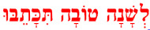

"May you be written down for a good year" (Rosh Hashanah greeting)

Rosh Hashanah The head of the new year
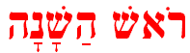

Yom Hadin The Day of Judgment

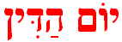

Yom Hazikaron
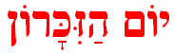
The Day of Remembering

Yom Truah
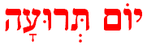
The Day of Blowing the Shofar

Shofar
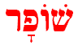
Ram's horn

Machzor
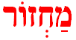
Prayer book used on
High Holy Days
Tashlich
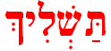
Ceremony of casting away one's sins

RABBI AMNON'S UNESANEH TOKEF

Unesaneh Tokef is a prayer recited in the Musaf service of Rosh Hashana and Yom Kippur, just before Kedusha. It is one of the most stirring and emotional prayers of the entire Yomim Noraim. Written by Rabbi Amnon of Mainz, Germany, about one thousand years ago, the prayer describes the Yomim Noraim as a time of judgment, where people symbolically pass before Hashem. In the prayer, there is an listing of the possible fates that may befall people, but it also includes an emphasis on Hashem's attribute of forgiveness.

This is the story behind it.
Reb Amnon lived in the town of Mainz, and was well known throughout the area for the righteous way in which he lived his life.
The bishop of Mainz heard of the rabbi and wanted to see him. Reb Amnon visited the bishop and spoke to him about religion. The bishop was deeply impressed by the rabbi's piety and determined that such a good man should be his friend and advisor. He also insisted that he leave the Jewish religion and convert to Christianity. The bishop gently argued with Reb Amnon, trying to show how his faith was superior to Judaism. The bishop held out bribes to Reb Amnon that fame and money would be his only if he would convert. Reb Amnon remained steadfast. He responded to each request with a simple "No."
The bishop soon dispensed with gentleness. "You are as stiff-necked as all your people! You can be sure that I will quickly end your stubbornness and make you do as I wish."
A couple of days after their first encounter the bishop summoned Reb Amnon. When Reb Amnon arrived, the bishop confronted Reb Amnon. "Accept my faith or you will definitely die!"
Reb Amnon felt afraid and said to the bishop, "Give me only three days to think about the matter -- then I shall bring you my answer."
"So be it," the bishop agreed.
Reb Amnon returned to his home. He put on sackcloth and ashes. He fasted and prayed, distraught at having given the impression that he even considered betraying Hashem. Three days passed, but Reb Amnon did not return to the palace. The bishop was astonished. "Is the Jew not afraid?" he said to his personal guards. "He has defied my will. Quickly go and bring him to me, that I may judge him."
The guards hurriedly seized Reb Amnon and brought him to the palace. The bishop confronted the rabbi, who remained frightened for his life. "Jew, how dare you disobey me? Why have you broken your promise to bring me your answer after three days?"
Reb Amnon looked up sadly. "In a moment of weakness I fell into sin and lied and made false promises. To save my life without defying my faith I sought the cowardly grace of three days in which to give you my answer. I should have said right away to you, Shema Yisroel Hashem Elohaynu Hashem Eh-chad ('Hear, O Israel, Hashem is our G-d, Hashem is one'), and then perished at your hands."
The bishop was angry. "Your feet disobeyed me by not coming to the palace. For that, they shall be torn from your body."
"No," Reb Amnon said. "My feet should not be torn, but rather my tongue for it betrayed Hashem."
"Your tongue has uttered the truth, and therefore will not be punished."
The furious bishop ordered that R' Amnon's feet be chopped off, joint by joint. They did the same to his hands. After each amputation R'Amnon was asked if he would convert, and each time he refused. Then the bishop ordered that he be carried home, a maimed and mutilated cripple, together with his amputated parts. Soon the rabbi began to die of his wounds. When Rosh Hashana arrived a few days later, R' Amnon asked to be carried to the synagogue.
Once there, he asked to be taken to the Ark. Before the congregation recited Kedusha, he asked to be allowed to sanctify Hashem's name in the synagogue as he had in the bishop's palace. He recited Unesaneh Tokef and died just as he finished the last words of the prayer.
Three days later, Reb Amnon appeared in a dream to Reb Klonimus ben (the son of) Meshullam, a great Talmudic and Kabbalistic scholar in Mainz, and taught Reb Klonimus the text of Unesaneh Tokef and asked him to send it to all the Jewish people to be recited in the Musaf service of Rosh Hashana and Yom Kippur, just before Kedusha. Reb Amnon's wish was carried out and the prayer has become an integral part of the Rosh Hashana and Yom Kippur services.

The following is a translation of selections from this prayer:
We shall now speak of the power of this day's holiness,
for it is awesome and frightening...
It is true that You alone are the One Who judges, who proves, knows and testifies, writes and seals,
And remembers all that is forgotten...
All creatures of the world will pass before You like sheep...
On Rosh HaShana shall be written and on Yom Kippur shall be sealed
how many will pass from the world and how many will be created,
who will live and who will die,...
who by water, who by fire, who by sword, who by beast,
who by famine, and who by thirst...
Who will rest and who will wander...
who will become poor and who will become rich,
who will be lowered down and who will be lifted up.

And teshuva, prayer, and charity remove the evil of the decree!

...For You do not desire the death of he who deserves death
but rather that he should return from his way and live.
Until the day of his death You wait for him,
if he returns You accept him immediately....
The Story
of the
Star Fish
A man was jogging down the beach after a major storm had just come through the area. He was dismayed by the huge number of starfish that the storm had washed up on the beach. He thought that there was nothing he could do because of the immense numbers. As he continued down the beach he saw an old man throwing something into the water.

As he got closer, he saw the old man walk a little farther down the beach, bend over, pick up a starfish and throw it back into the water. As the jogger approached, the old man stopped again, bent over, picked up another starfish and was about to throw it into the water.

The jogger stopped and asked "Why are you doing that? There are thousands of starfish on the beach. You can't possibly make a difference." The old man looked at the starfish, threw it back into the water, then replied, "I made a difference to that one, didn't I?"



Footsteps in the Sand
One night a man had a dream.
He dreamed he was walking along
the beach with the Lord.
Across the dark sky flashed scenes from his life.
For each scene, he noticed
two sets of footprints in the sand,
one belonging to him and the other to the Lord.
When the last scene of his life flashed before him,
he looked back at the footprints in the sand.
He noticed that many times along the path of his life
there was only one set of footprints.
He also noticed that it happened at the
very lowest and saddest times in his life.
This bothered him and he questioned the Lord about it.
"Lord, you said that once I decided to follow you,
you'd walk with me all the way.
But I have noticed that during the most
troublesome times in my life there is
only one set of footprints.
I don't understand why when I needed you most
you would leave me."
The Lord replied "My precious, precious child,
I love you and would never leave you.
During your times of trial and suffering,
when you see only one set of footprints in the sand,
it was then that I carried you."

© Published by Woodside Park Synagogue 2006, 5767

The fireman.

Many years ago, every town had a tower in which sat a guard that alarmed all of the citizens when a fire broke out. When people heard the trumpet they immediately ran to the river and filled up buckets
of water to extinguish the fire.
Once upon a time a foreign young man visited one of those towns. Suddenly he had heard a trumpet. The young man did not understand what has going on around him. The town’s citizens explained to
him: when a fire brakes out, the guard blows the trumpet. This way everybody knows
there is a fire and they run to extinguish it.
The young man liked that idea very much and decided to import it to his hometown. What did he do? He set one of his town’s roof on fire. The fire spread quickly from one roof to the other. He stood and blew the trumpet loudly in order to try and stop the fire. But the fire did not go off and all the houses were burned to the ground.
The town people got very mad at him and told him: don’t you understand that the trumpet does not extinguish fire. It is only a signal, a sing that awakens the people so that thay will get up and put off the fire.

This story is a parable for blowing the shofar. We need to understand that hearing the shofar is insagnificant. The shofar is only a sing that we are to make up, we are to go over our dids in order to correct the bad ones.

Snake quiz / taf

Goal: knowing basic concepts about the shofar

Snake game board divided to numbers. The group splits in two-three small teams. Each team gets its own pawn The “Madrich/a” will get the questions written on cards. Each team will choose a representative (this will be a competition so it is better to notify the kids about it’ so they could choose the fastest “chanich” as their representative), his job is to run and deliver the questions to his team each time. The three representatives will get the first question at the same time and run to their team. Together the team will try to find out what is the answer, and when they come to conclusion, the runner will run as fast as he can, and whisper the answer to the “madrich/a”. If the answer is correct the “madrich/a “ will give him the next question and will move the pawn one spot ahead.
The first team that will reach to the end of the snake will be the
WINNER.

1. Its job is to remind us to do "Tshuva” – “Shofar”
2. When do we begin blowing the “Shofar” – “Rosh Chodesh” “Elul”
3. The three kinds of the shofar blowing – “tekia”, “shvarim” , terua”
4. Name another event when we blow the shofa – “Yom Kipur”.
5. How many blows do we hear in one day of “Rosh Hashana” – 100
6. What is the written text in the “Torah” from where we learn about the “Shofar” – “Akedat Izchak”
7. In “Chodesh Elul”, in which day we will not blow the Shofar – Rosh Hashana eve.
8. What material The Shofas is made of – Rams horn.



First shabbat – “Heshbon nefesh”
Goals:
1. Bringing the “chanich/a” to be aware of his /her qualities, characters
and distinguish between his/her negative and positive qualities.
2. Understanding the meaning of the concept "Cheshbun-Neffesh” and it's importance.

Instruction:
1. All of the chanichim sit in a circle. The chanichim pass the mirror between them. Every chanich/a in his/her turn, is asked to tell one good quality that characterize him, and one bad quality that he aware of having it, and willing to change it.
It very crucial to let the chanich/a speak only about himself, and not
allowed responses from the others.
2. Discussion: The madrich/a will discuss with the chanichim abou the following questions connecting to the activity they just went through:
* Was it easy for you to find a negative quality you own?
* Which quality you were most aware of – the negative or the positive?
* What you need to do in order to improve your negative qualities?
3. Before the “Pe’ula”, the madrich/a will scatter the stones he was given around the room. After the discussion, the “madrich/a” will ask for 4 volunteers- two of them will be asked to pick 10-15 small stones into a bag, and the other two will be asked to pick 2 big stones. After that the
madrich/a will tell the first part of the story:

Part one:
Once upon a time there was a "Tzadik", an old man that everybody
admired him. Many people came to him to confess their sins, and to get his blessing. Once, two women came to him. One of the women started confessing about a big sin she had done: “I already went asking for forgiveness from the person I have hurt. But my conscience is still bothering me. I know that the man had forgiven me, but how can I know whether G-d forgave me? My sin is very severe, and my only wish is that G-d will forgive me.”
The Tzadik listened silently, then turned to the other woman and asked her, “What about you? Why are you here?”
The woman answered: I just came to escort my friend.
“And what is your wish?” The Tzadik asked.
“To get your blessing.”
“Very well,” the Tzadik replied. “My blessing is given to you. I see that you have nothing to confess.”
“My conscience is clear,” the woman said. “Baruch Hashem, I only have minor sins, and I don’t want ot waste your time telling you about them.”
Then the Tzadik turned to the other woman and said,”I see that you have truly repented before Hashem, and this is what I ask you to do: go to my backyard and pick up the biggest stone you can carry and bring it to me for you have sinned a great sin.”
And from the other one he asked,” you go too, and collect as many little stones as you can, for your sins were minor.”
The two women ran outside and did as they were told. The Tzadik looked at the stones and said, ”You have done well. Now, if you may, please return the stones to their exact previous location, come back, and I shall say my words.”
-After the first part the madrich/a will ask for volunteers to return the stones they picked to the exact location, and after that continue with the second part of the story.

Part Two:
The two did as the tzadik oredered and came back. The first found the location very easily and palced the stone back in its place. The other woman, no matter how hard she tried, could not determine the location and returned with her pile of stone, and then the old man said, “Now I shall tell you my word – you the first one, have replaced the stone because you remembered where you took it from. The same thing about your sin. You remember it, tortured your soul, and suffered. You were ashamed for it and wanted to do teshuva. But you weren’t ashamed to admit and God has forgiven you. And you, the one with the little stones, apparetnly had only minor sins, and your conscience didn’t bother you at all. Therefore, you didn’t remember your sins, and didn’t make your ways better, and perhaps even lectured others, how could Hashem for give you?”

4. Discussion: The madrich/a will conduct a final discussion.
*Which one of the volunteers had an easier job putting the stone back in its place? Why?

In the middle of the discussion, the madrich/a will compare the stones to sins, the big stones to big sins and the little stones to minor sins. The madrich/a will have to emphasize the fact that we can't really decide what is a big sin and what it a minor one, and why the woman with apparently minor sins was wrong.

*What are the minor sins that the woman referred to? (swearing, insulting, etc.)
At the end of the discussion the madrich/a will need to talk about heshbon hnefesh and the importance of it. Explain that in order to do a complete teshuva, you have to do a heshbon nefesh and try to improve yourself. The madrich/a will refer to the second woman, the one with the minor sins, and say, because she was in denile, she couldn’t make a complete teshuva, and make up for her sins, and that’s why it was so difficult for her to find the place of each stone. But the first woman who knew exactly what she had done wrong, could make a teshuva because of the heshbon nefesh. She knew how to find her stone’s previous location.

I am a symbol for the 'sweet' year we pray on having

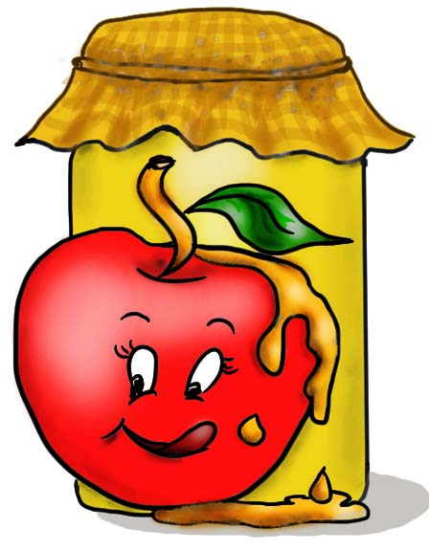

I am a symbol for all the good deeds we aspire to do this upcoming year

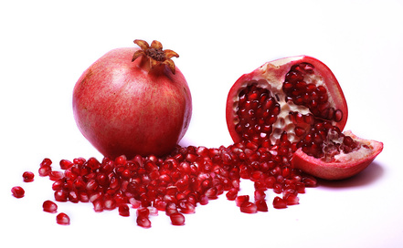

My sound announces the arrival of the new year.

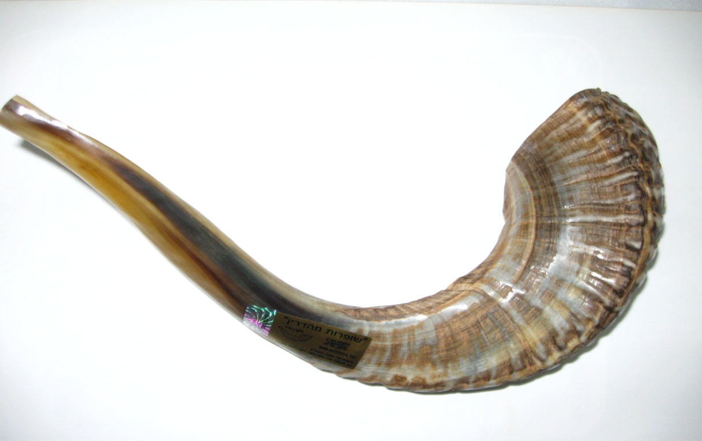

I am the day Rosh Hashana is celebrated

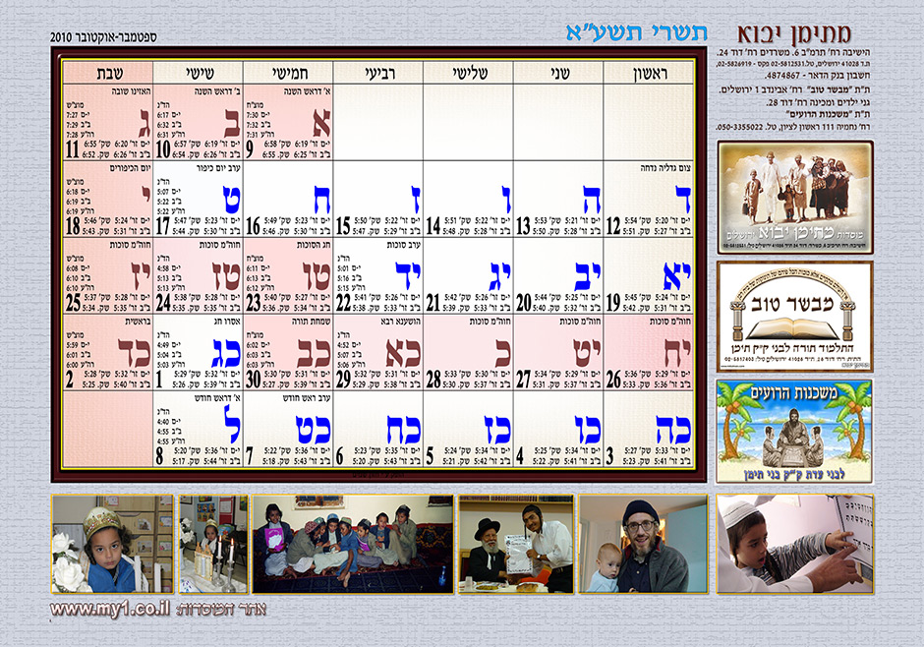

My horn is used as a Shofar

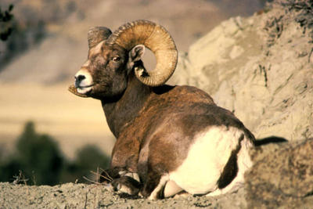

I am a symbol for the end of our enemies

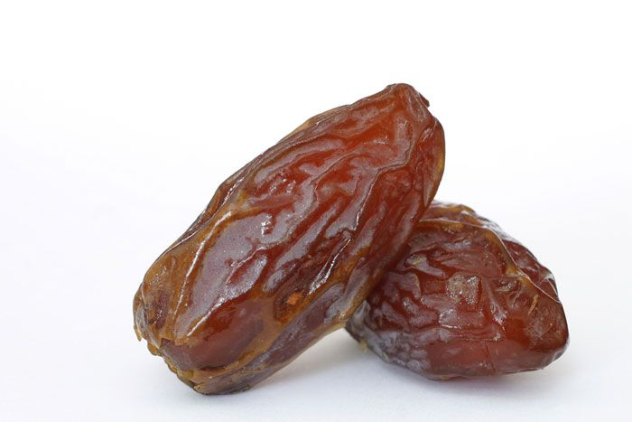

My head is a symbol for success

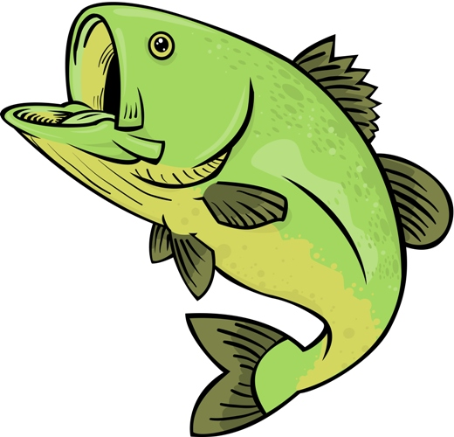

My head is a symbol for success

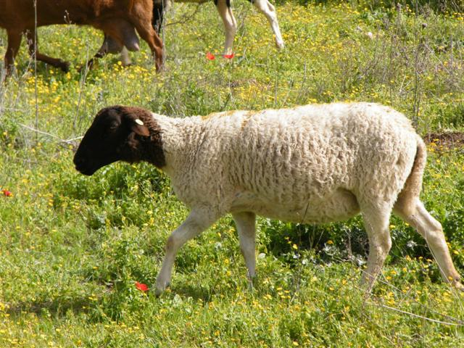

I used to be the first month of the year during biblical times

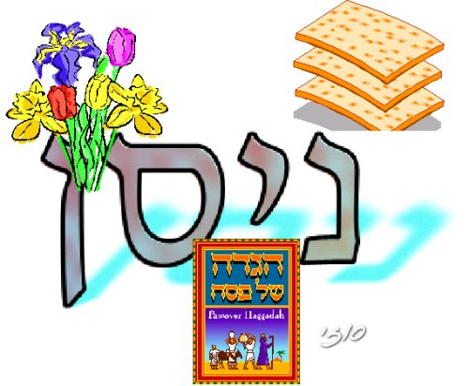

I am the literal translation of the word ‘Rosh’

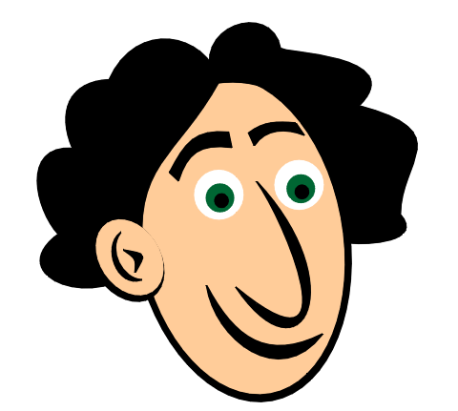

People exchange me near Rosh Hashana

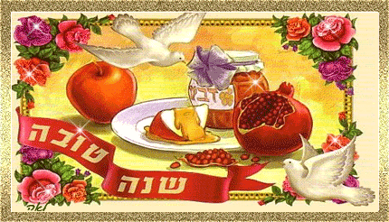

People come here to cleanse themselves of their sins before the new year

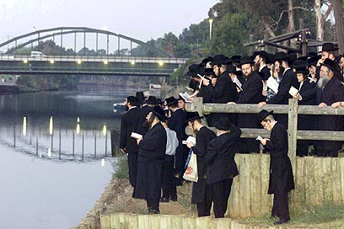
I am a part of your Shabbat dinner every week, but during Rosh Hashana I appear in a different shape

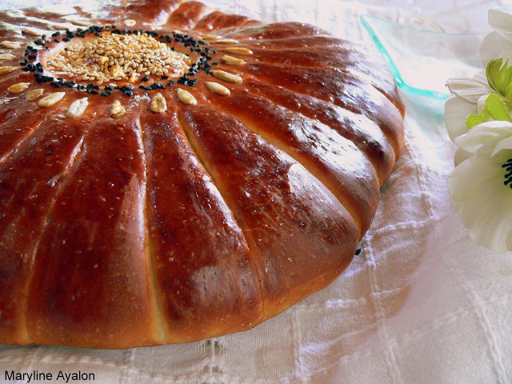

תפוח בדבש

רימון

שופר

א' בתשרי

איל

תמר

דג

כבש

חודש ניסן

ראש

כרטיס ברכה

נהר

חלה

