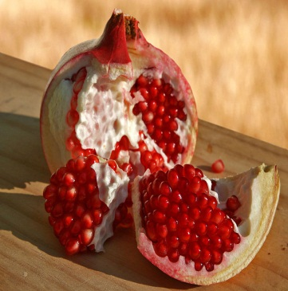

Pomegranate:

Pomegranates are said to have 613 seeds, the same number as mitzvot in the Torah. On Rosh Hashanah we eat a fresh pomegranate preceded by the blessing:

A prayer for the state of Israel:

אָבִינוּ שֶׁבַּשָּׁמַיִם, צוּר יִשְׂרָאֵל וְגוֹאֲלוֹ, בָּרֵךְ אֶת מְדִינַת יִשְׂרָאֵל, רֵאשִׁית צְמִיחַת גְּאֻלָּתֵנוּ. הָגֵן עָלֶיהָ בְּאֶבְרַת חַסְדֶּךָ, וּפְרֹשׁ עָלֶיהָ סֻכַּת שְׁלוֹמֶךָ, וּשְׁלַח אוֹרְךָ וַאֲמִתְּךָ לְרָאשֶׁיהָ, שָׂרֶיהָ וְיוֹעֲצֶיהָ, וְתַקְּנֵם בְּעֵצָה טוֹבָה מִלְּפָנֶיךָ. חַזֵּק אֶת יְדֵי מְגִנֵּי אֶרֶץ קָדְשֵׁנוּ, וְהַנְחִילֵם אֱלֹהֵינוּ יְשׁוּעָה וַעֲטֶרֶת נִצָּחוֹן תְּעַטְּרֵם, וְנָתַתָּ שָׁלוֹם בָּאָרֶץ וְשִׂמְחַת עוֹלָם לְיוֹשְׁבֶיה ונאמר: אמן.

Avinu shbashamim, zur Israel v’egoal, barech et medinat Israel, reshiy tzmichat geulatenu. Hagen aleyha b’avrat chasdecha, u’pros aleyha sukat shlomecha, u’shlach urcha v’amitcha l’rasheyha, sareyha v’yoatzeyha, u’taknam b’etza tova mlfaneycha. Chazek et ydey meginey eretz kodshenu, v’hanchilam eloheynu yeshua v’ateret nitzachon tatram, v’natata shalom baretz v’simchat olam l’yoshveyha. V’nomar Amen

Our Father in Heaven, Rock and Redeemer of the people Israel; Bless the State of Israel, with its promise of redemption. Shield it with Your love; spread over it the shelter of Your peace. Guide its leaders and advisors with Your light and Your truth. Help them with Your good counsel. Strengthen the hands of those who defend our Holy Land. Deliver them; crown their efforts with triumph. Bless the land with peace, and its inhabitants with lasting joy. And let us say: Amen.

Common Rosh Hashanah Blessings in Israel:

שנה טובה ומתוקה Shanah tova u’metuka - a good and sweet year

תכלה שנה שנה וקללותיה, תחל שנה וברכותיה

Techale shanah u’klaloyeiha, tachel shanah u’birkoteiha.

There ends a year and its maledictions and a new one begins with its blessings

Rosh Hashanah signs:

Symbolic foods are served at a Rosh Hashanah dinner. Some of these foods are also puns, and are called “simanim,” or “signs.” Special blessings called “Yehi ratzones,” Hebrew for “May it be God’s will,” are chanted over these dishes. Here are some of them, and the traditions associated with them 🡪

Rosh Hashanah In Israel

"יהי רצון מלפניך אדוני אלוהינו שנהיה מלאים זכויות כרימון"

Yehi Ratzon Mil’fa’necha, Adonai Eloheinu she nihiye meleim mitzvoth ke rimon”

May if be your will Adonai our God that our merits increase like the seeds of a pomegranate”.

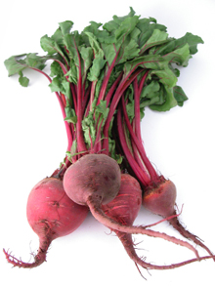

"יהי רצון מלפניך אדוני אלוהינו שנהיה לראש ולא לזנב"

”Yehi Ratzon Mil’fa’necha, Adonai Elohein She niyeh le rosh velo le zanav”

“May if be your will Adonai our God that we will be the head and not the tail”:

"יהי רצון מלפניך אדוני אלוהינו שיסתלקו אויבינו ושונאינו"

“Yehi ratzon milfanecha Adonai Eloeinu she istalku oyevenu ve soneiynu”.

May it be your will Eternal God that our enemies and haters will be removed”.

Beets:

The Aramaic for beets is “silka” which sounds like the Hebrew word “siluk.” ”Siluk” means removal. We pray that our enemies will be removed.

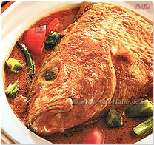

Head of a fish:

. It is a very ancient tradition to bake and present at the table the head of a ram. This is done to symbolize a desire for the Rosh Hashanah celebrants to be leaders, not followers.

"יהי רצון מלפניך אדוני אלוהינו שנהיה לראש ולא לזנב"

”Yehi Ratzon Mil’fa’necha, Adonai Elohein She niyeh le rosh velo le zanav”

“May if be your will Adonai our God that we will be the head and not the tail”.



* The technology for the AOL Instant Messenger and ICQ was developed in 1996 by 4 young Israelis.
* The cell phone was developed in Israel by Motorola, which has its largest development center in Israel.

Startup nation

As we begin a new year look at some of the things that began in Israel…

* An Israeli company M-Systems was the first to patent and introduce key chain storage (jump drive).
* the PillCam - the first ingestible video camera. Used to view the small intestine from the inside, the camera helps doctors diagnose cancer and digestive disorders.

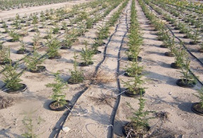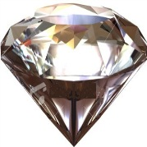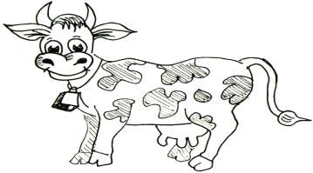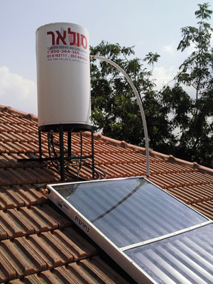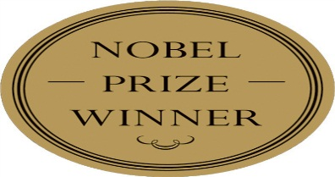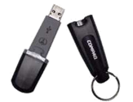

*Head and not tail*

*Israel is leading the way…*

* Israel is one of only 8 countries in the world capable of launching their own satellites into space.
* Over 90% of Israeli homes use solar energy for hot water. The highest percentage in the world.
* Israel is the only country in the world to have free trade agreements with the US, Mexico and Canada as well as the European Union and the European Free Trade Association, at the same time.
* Israel has more Nobel prizes per capita than any other country except Switzerland.
* Twenty-four percent of Israel’s workforce holds university degrees – ranking third in the industrialized world, after the United States and Holland.
* Israel has the world's second highest per capita of new books published per year.
* Israel has more museums per capita than any other country.
* Israel 's dairy cows are the most productive dairy cows in the world. They average 25,432 pounds of milk per cow per year, compared to just 18,747 pounds from American cows
* The Israel national trail was recently chosen by *National Geographic* as one of the world’s 20 best hiking trails.
* Israel was the first nation in the world to adopt the Kimberly process, an international standard that certifies diamonds as "conflict free."
* Drip irrigation - the system that is based on using plastic pipes that release small amounts of water next to crops or plants - was developed by the Israeli engineer Simcha Blas in the 1970's. The invention caused a revolution in agriculture.