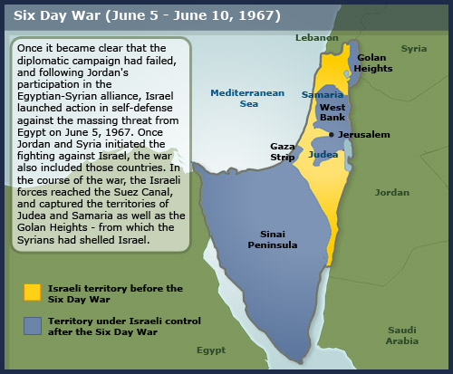
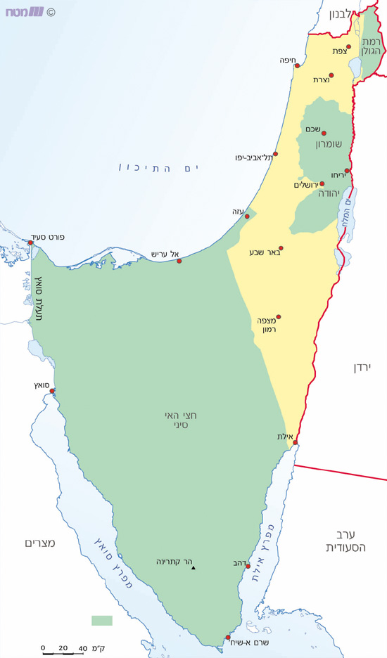
1
After 67, supposedly, the IDF and the State of Israel came to tranquility in this sense that at last there was a discrepancy, between IDF's desired Israel protection boundaries and what he holds in practice. IDF holds the Golan Heights, the Sinai Peninsula and the Suez Canal, the West Bank and Gaza.
2
But no one asked: How the IDF will defend those defensible borders? And from where he will bring enough troops to protect those borders effectively? The answer is becoming clearer after the war: The army doesn't have enough soldiers - "the blanket is too short."
3
This is serves as background to the acute debate, inside the IDF and Israeli government. The government talked about what to do with the territories conquered in 67. Should Israel use them as cards in peace negotiations with Arab states? Or should Israel stay at those territories and never leave? At the IDF, the debate is on shaping Israel's defense borders.
4
It is very clear to both statesmen and generals that Israel will probably absorb the first blow in the next war. Since the 67 war, Israel is subjected to political isolation. Even her most important ally warns her that in the next war it should be clear to everyone, without any doubt, who was the aggressor…
5
The IDF Report on the 67 War: "The next war will look just like the war that has just ended".
6
In the spring of 1973, the prevailing attitude in the IDF was "Be my guest," as enunciated by IDF chief of staff, David Elazar. He said an Arab attack would be exploited as an opportunity to improve Israel's position, even if it meant reaching Damascus and Cairo.
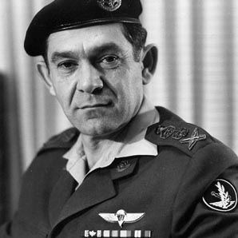
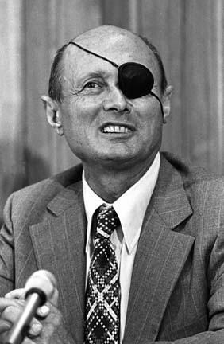
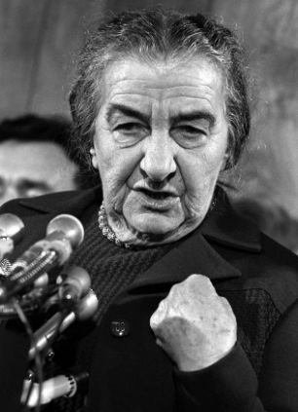
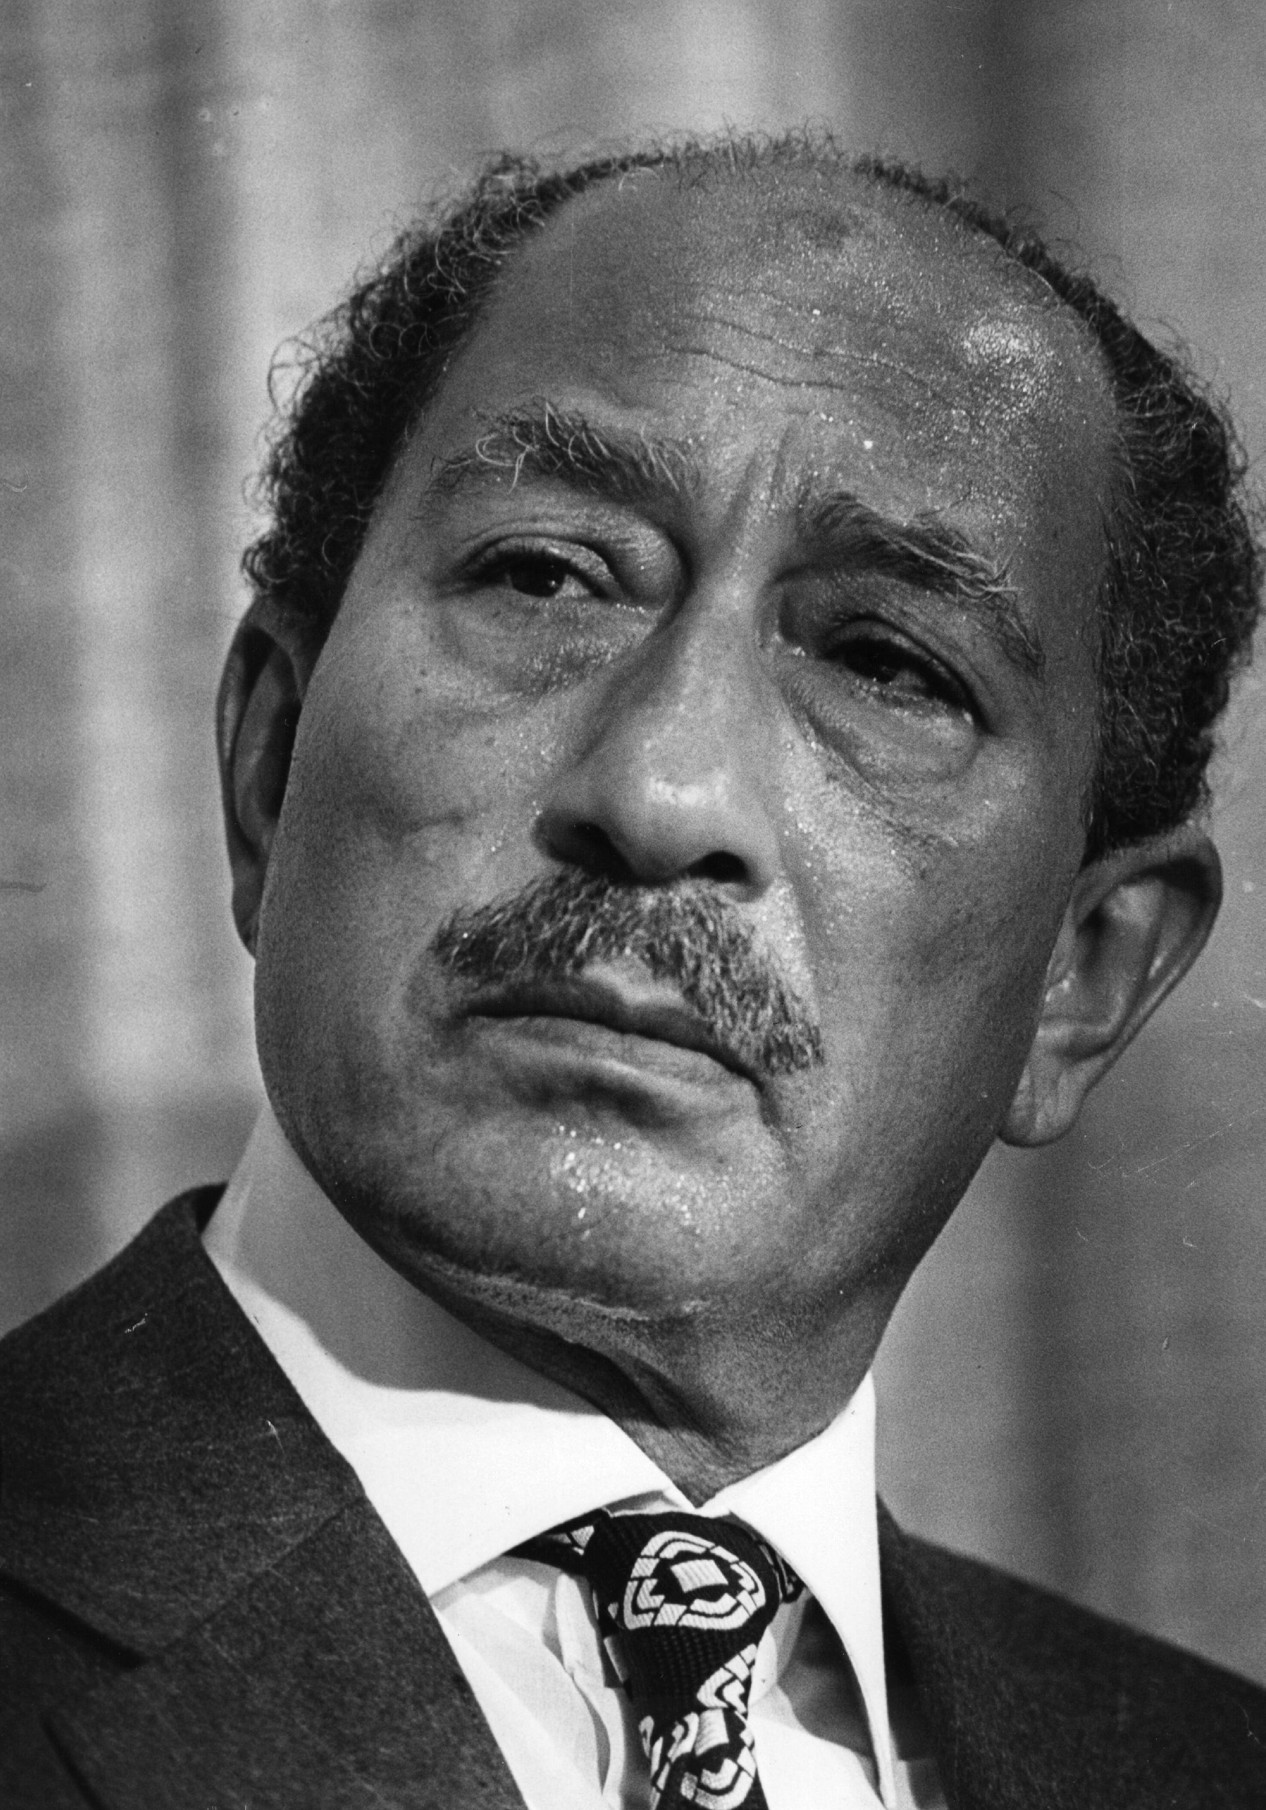
7
October 6, 1973, Yom Kippur, 8:05 A.M.
The morning of the Yom Kippur War, just six hours before the dramatic outbreak of the deadly clashes, Israeli Prime Minister Golda Meir's cabinet is assembled for emergency consultation and meets with IDF chief of staff David Elazar, commonly known as 'Dado', as well as IDF Intelligence chief at the time Eli Zeira. Dado informs the ministers of a dramatic message relayed by Egyptian billionaire Ashraf Marwan, who spied for Israel, of the impending war. He continues saying that the message is authentic. The warnings of the intelligence source were being taken seriously, as was the fact that the Russians were pulling families out of Egypt and Syria, a sign of approaching war. But U.S. intelligence was not predicting war.
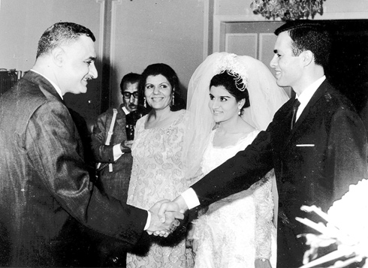

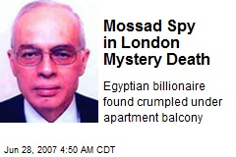
8
Minister Yisrael Galili said that the source had suggested the war could be prevented by leaking information that would reach the Egyptians and Syrians, so they would knew their plans for attack had been discovered. Jordan also preoccupied those in attendance, because it wasn't clear if the kingdom would join in the assault on Israel.
9
The advantage of a pre-emptive attack:
The possibility of launching a preemptive strike is raised throughout the meeting. Dado says such a strike would give Israel "a huge advantage and save many lives. If we get into a war where the first stage is to block - and I am sure that we can do this - then after the attack, there will be a serious war."
10
"We can wipe out the entire Syrian air force at noon. We need another 30 hours to destroy the missiles. If they plan to attack at 5 pm, the Air Force will operate freely against the Syrian army. This is what we are capable of," says the army chief. "From an operational standpoint I am very tempted. We don't have to decide now. We still have four hours for dialogue with the Americans. Perhaps by noon the Americans will tell us that an (Arab) attack is certain, and then we may be able to launch the pre-emptive strike". Elazar gave then-prime minister Golda Meir, defense minister Moshe Dayan, and head of intelligence Maj.-Gen. Eli Zaira, four hours to talk to the US and make a decision.
11
Dayan against a pre-emptive attack:
Dayan explains why Israel should not launch a preemptive strike, as it did in the Six Day War. "We cannot afford it this time. If the Egyptians attack, we'll be able to attacks the Syrians. Based on the information I have obtained, we cannot launch a preemptive strike. Not even five minutes beforehand. If we'll be in a situation whereby Egypt starts (the war), we'll be able to strike Syria as well. If they don’t open fire, we won't open fire."
12
The Israeli overconfidence
On the day the war broke out, Yom Kippur, the chief of military intelligence, Eli Zeira, was still expressing the belief that Egyptian president Anwar Sadat would not start another war with Israel. Throughout the meeting, IDF Intelligence chief Zeira says he is still uncertain whether a war will break out. "Despite the fact that they are prepared, I believe that they know they will lose. (Egyptian president Anwar) Sadat is not in a position whereby he has to go to war." The head of IDF Intelligence protrudes with his overconfidence, saying the enemy won't attack – "They know they will lose."
13
Prime Minister Meir asks whether the current situation is different from the one Israel faced on the eve of the Six Day War. Zeira in response: "(Sadat) has not given the order yet. He may back down at the last minute. We may be able to influence what he does or decides."
14
Talking about mobilization
IDF chief Elazar says the army reserves must be called up immediately, but Dayan replies, "I believe we can complete the call-up tomorrow. It's not like in 1967. The war will begin in the Suez and Golan Heights. It is important that they don't say we started (the war). "I suggest calling up all of the Air Force reserves, as well as Armored Corps division in the Golan and another in Sinai. This can amount to 50,000-60,000 people. We can complete the limited call-up by this evening and have the forces prepare for action until tomorrow morning. If during the night we want to call up more – we will," says Dayan.

15
"Israel will be packed and the streets will be full, etc. I believe that we can call up the reservists tomorrow. It's important that [the world] doesn't say we started. Calling up all reservists before even one bullet was shot - everyone will say we were the attackers," Dayan explained. "If you approve a major mobilization of the reserves, I won't resign," Dayan said. But with an eye to international reaction, he added, "A full mobilization before even one shot is fired - they will say right away that we are the aggressors."
16
Dado says 200,000 soldiers must be called up. "If they attack in 10 hours, we are as ready as possible with regular soldiers, but we did not call up any reserves at all. The IDF's power is 25 percent regular and 75% reserves. Therefore, we need to increase our power immediately. We need at least 24 hours to call up reserves - those that are called up now, can be put into action tomorrow". "As far as the international-diplomatic impact is concerned, it doesn’t matter if we call up 70,000 or 200,000. Actually, it may have an effect, because the Arabs will understand that they've lost the element of surprise. On the other hand, a call-up incriminates us. They'll say we called up (reserves) to start a war. I prefer that they say we started (the war) and we win. They'll say it anyway".
17
Initially, Meir deliberated between Elazar's call for a full mobilization of the reserves and Dayan's request for a limited call-up. Golda decides on a gradual call-up, and says that a preemptive strike is "very tempting, but this is not 1967. They (international community) won't believe us". As the meeting progresses, Golda is more inclined to accept the IDF's suggestion for a broad call-up. "If a war breaks out, we must be in the best possible position. This is my only concern". Despite that view, and against the recommendations of then-defense minister Moshe Dayan, Meir decided to mobilize 200,000 reserve soldiers so as to provide a substantial boost to the military in the event that war broke out.
18
At 9:20 A.M., a full mobilization was approved. The failure to call up reserves is often cited as one of the IDF's major mistakes in the Yom Kippur War.

19
Help from the U.S
October 7, 1973
A discussion at the Prime Minister's Office centered on how to enlist American support at the United Nations and head off a cease-fire that would hurt Israel. Meir suggested putting together a list of requests. Meir and senior defense officials also worked to procure additional military hardware, in the form of 40 fighter jet and 400 tanks, from the United States. The prime minister even considered a secret meeting with U.S. president Richard Nixon without the knowledge of the cabinet, in an effort to convince the American leader to come to Israel's assistance.
20
The forum considered presenting U.S. secretary of state Henry Kissinger with a partial, distorted picture exaggerating Israel's poor situation to win the Nixon administration's support. Meir rejected the suggestion out of hand. "We should telegraph him the details; he should get the real picture," she said. "We can't play hide and seek with him. "Minister Yisrael Galili asked in response, "Do we sell him the fact that we've moved out of the populated areas?" Meir replied, "I don't object to us saying, there's also risk to populated areas ... I want to give him the real picture. I'm not under the impression the situation is doomed ... We should tell it to him convincingly. Tonight was a bad night."
21
Agranat commission:
The Agranat Commission was the first to raise the question of the decision-making process in Israel and the lack of competition to army divisions. The Commission found that Israel should have more resources, more reviews, more processing, and do not rely solely on IDF intelligence crops. The intelligence crops assumption was that if Egypt starts a war, it does so in order to conquer the entire land of Israel. They didn't understand that the Egyptian president didn't want to conquer Israel, but to cause Israel to sit at the negotiating table and accept Egypt terms.

22
Diplomats may have been able to understand Sadat's strategy before Yom Kippur, or perhaps even Mosad experts were able to see it. So, the Agranat Commission recommends: Israel must give rise to additional assessment centers outside the army - try to do what the Army does, but consider it from another prospective. Moreover, the Agranat Commission recommended the establishment of a body within the research division of Intelligence crops - called "inverted Versa" - whose job will be to take all data and facts the research division relies on and create the opposite view.

